Three Rivers Community College
ECE K176 Health, Safety and Nutrition
Course Materials

Fall 2019

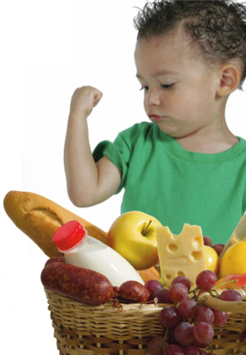

Dr. Jennifer Nally
jnally@trcc.commnet.edu

Phone Number: 860-383-5214
Office Number: C110

Office Hours: Monday and Wednesday or by appointment

Course Description:
Prerequisite: ENG* K101 eligibility; ECE* K101 and ECE* K182 recommended. The relationship between health, safety and nutrition and child development will be examined. Emphasis will be on the strategies needed to implement a safe, healthy and nutritionally sound program. Community agencies and resources that benefit the children through these domains will be explored through community service experiences.

Required Text(s):
Robertson, Cathie. (2016). Safety, Nutrition and Health in Early Education. 6th Edition. Wadsworth.
ISBN: 978-1-305-08890-0
Additional readings will be assigned throughout the semester.

Course Objectives:
- Acquire knowledge concerning health, safety and nutrition issues in early childhood classroom environments.
- Develop skills necessary to plan and implement health, safety and nutrition experiences and to integrate these experiences into the daily curriculum.
- Become aware of Connecticut State Licensing regulations concerning health and safety in an early childhood center.

Course Outcomes:
- Candidates will know and understand children’s needs as it relates to health, safety and nutrition. (NAEYC Standard 1.a)
- Candidates will recognize the importance of engaging diverse families to support their role and build relationships. (NAEYC Standard 2.a and 2.c)
- Candidates will analyze the importance of being a continuous and collaborative learner. (NAEYC Standard 6.c)
- Candidates will understand the state licensing regulations and the role each individual plays in meeting these standards. (NAEYC Standard 6.a)

General Education Goals:
- Candidates will develop the skills and abilities to communicate effectively in writing.
- Candidates will develop information literacy to assess what information is needed to answer questions and to retrieve, evaluate, and use that information effectively.

Policies:
If you have problems with the course or material, please see me or call to arrange for an appointment. Candidates who are not able to complete the course need to speak to me immediately as we will try to work together to have you complete the class successfully.

As part of the course, candidates will be required to spend additional time observing and/or working with children in actual or simulated child development settings.

Active participation in class discussions and activities is required. Candidates are expected to complete assigned readings prior to class and come to class prepared to discuss them. Throughout the course there will be other written assignments to help guide your studies which will be handed in and counted as part of your participation grade.

Class attendance is required. The greatest amount of learning occurs during class time, where group activities and interactive assignments allow for learning not covered by the text and required assignments. Attendance is taken at the beginning of class. Frequent absences will count against your attendance grade.

Candidates are urged to devote their time and energy to fulfilling stated class requirements. Please note that a credit hour ‘work expectation’ equates to one hour of classroom or direct faculty instruction and a minimum of two hours of out of class candidate work. So for this three credit course you should expect to spend a minimum of three in class and six out of class hours (total of nine hours) per week on this course in order to be successful.

Extra credit points may be considered if a candidate is active in the Future Educators Club, participates in early childhood events, or tutors / supports another classmate in their understanding of course content. Additionally, with prior permission, there may be an opportunity to redo and resubmit an assignment. These opportunities will be decided on an individual basis.

Take home tests will not be accepted beyond the scheduled due date. Make-ups for in class, scheduled tests are only allowed when planned in advance. Make-ups must be done in a timely manner.

It is assumed that all assignments will be completed and turned in on time. Ten percent of the grade (10%) will be deducted from a late assignment. Assignments will not be accepted beyond a one-week extension. Late assignments cannot be rewritten or resubmitted.

Spelling and grammar will be included as part of the grade for all written work. Thus, proper spelling and careful proofreading are important. A candidate's written work is expected to be original and done independently unless otherwise indicated. Citations and references must be used to acknowledge the source and avoid plagiarism. Violations of academic integrity will be referred to and dealt with in accordance with the college policy. Academic integrity is essential to a useful education. Failure to act with academic integrity severely limits a candidate’s ability to succeed in the classroom and beyond. In this class and in the course of your academic career, present only your own best work; clearly document the sources of the material you use from others.

TRCC has assigned you a college email address. Please familiarize yourself with this as this is the primary way the college communicates with you (course schedules, financial aid, etc.). In the past students have found it useful to set up their college emails to be forwarded to another place (email or iphone, etc.).

Lap top computers and tape recorders may be used during class time, with prior permission and for the purpose of note taking only. Computers and other forms of technology are prohibited during tests.

Cell phones, pagers, ipods, and other similar devices must be turned off during class. Texting or using your cell phones during class is not acceptable and you may be asked to leave the class.

The candidate is responsible for all materials covered in class as well as the assignments. If a candidate misses a class, it is the candidate’s responsibility to get the notes from another candidate. Do not contact the Instructor and ask for a review of the class. Learn to rely on your syllabus and / or another candidate. You may want to share your contact information with other candidates to help facilitate this process.

Candidates with documented disabilities are provided supportive service and accommodations to assist them with their academic objectives. Services are strictly confidential. Disability services may include individualized accommodations, advising, advocacy, counseling, technical assistant and / or referral information. Students are required to submit a Self Disclosure Form, provide documentation, and meet with a Disability Service Provider before the start of the semester, if possible. Please call the Counseling Center at (860) 215-9017 for more information. Students who may need academic accommodations should discuss options with the instructor as early as possible. You will need to provide written documentation of your disability to the Candidate Services Counselors (Disabled Candidate Counselor). Appropriate accommodations will be provided to candidates who have completed this procedure.

Please refer to the Institutional Policies available in the Office of the Dean of Student Development and Services as well as on line, which include regulations regarding candidate conduct and the disciplinary code.

The Board of Regents for Higher Education (BOR) in conjunction with the Connecticut State Colleges and Universities (CSCU) is committed to insuring that each member of every BOR governed college and university community has the opportunity to participate fully in the process of education free from acts of sexual misconduct, intimate partner violence and stalking. It is the intent of the BOR and each of its colleges or universities to provide safety, privacy and support to victims of sexual misconduct and intimate partner violence.

TRCC does not follow the local school closing schedule. The TRCC website offers the most updated information about school closings and / or early dismissals. It is recommended that all candidates sign up for the electronic notification system to receive instant alerts and messages. In the event that class is cancelled, separate from the college, the instructor may notify candidates using the Blackboard messaging system and / or the email contact available through TRCC.

“Never under estimate the power of a loving teacher.”
Taken from: Teachers Touch Tomorrow

Points given for requirements are as follows:

Please use this as a tool to keep a record of your progress in this course.
Assignment | Points | Due Date | Grade Received
Portfolio Assignment | 25
CPR / First Aid Certification (has an additional cost associated with this) | 25
Presentation | 24
Health, Safety or Nutrition Lesson | 15
Quizzes and Reflections | 15
Participation and Attendance | 15
Total | 119

Final Grade:
To determine your final grade take the total number of points awarded and review the following breakdown. This will be further explained.

Highly Competent A 101 – 119 points
Competent B 82 – 100 points
Minimally Competent C 63 – 81 points
D 45 – 62 points
F anything below 44 points

ECE K176 Health, Safety and Nutrition
Course Content and Study Guide
Week | Dates | Activities / Assignments | Reading | Key Concepts
1 | 8/28 | Welcome and Introductions  Developing the course expectations  Course Outcomes and Objectives Activity |  | confidentiality  participation
2 | 9/4 | No class Monday  Review Assignments |  | presentations
3 | 9/9  9/11 |  | Chapter 1 | holistic approach
4 | 9/16  9/18 | Presentation: Developmental and Physical considerations for children’s safety | Chapter 2 | safety environments
5 | 9/23  9/25 | Reality Check: How Safe are America’s Toys?  Article Review: Brain Development in Children  Safety Lessons | Chapter 3 and 4 | indoor and outdoor safety
6 | 9/30  10/2 | Presentation: Disaster preparedness and children | Chapter 5 | Emergency response
7 | 10/7  10/9 | Quiz  Dietary Record Activity | Chapter 6 | nutrition
8 | 10/14  10/16 | NAEYC VISIT  Presentation: Food Insecurity  Out of class activity for Wednesday | Chapter 7 | nutritional challenges
9 | 10/21  10/23 | Presentation: Subsidized food programs and children’s nutritional needs  Reality Check: Electronic Media and its Effects…  Article Review: Early Sprouts: Establish Healthy …  Nutrition Lessons | Chapter 8 and 9 | wellness  diverse nutritional needs  menu planning
10 | 10/28  10/30 | Presentation: Health Policies (licensing included)  Article Review: How mothers in cultural groups | Chapter 10 | health policies
11 | 11/4  11/6 | Quiz  Presentation: Parents and Immunizations  Portfolio Assignment Due | Chapter 11 | illness prevention  infection control
12 | 11/11  11/13 | Presentation: Childhood Communicable Diseases  Reality Check: Helping Vulnerable Children… | Chapter 12 and 13 | supportive health care  special health care
13 | 11/18  11/20 | Presentation: DCF and Mandated Reporting | Chapter 14 | DCF  child maltreatment
14 | 11/25 | Presentation: Program Policies  CPR / First Aid Certification Due  No class on Wednesday
15 | 12/2  12/4 | Presentation: Impact of Stress on Children  Reality Check: Relationship-Based Care in EC… | Chapter 15 | mental health
16 | 12/9  12/11 | Quiz  Health Lessons
This syllabus is subject to change. Any changes will be announced in class.

ECE K176 Health, Safety and Nutrition
Resource List
Dr. Jennifer Nally

______. (1997). FYI. Safety for child passengers. Young Children. NAEYC.

______. (2000). Protecting children from infections: A guide for day-care providers. National Association of Child Care Professionals.

______. (2006). Healthy and Balanced Living Curriculum Framework: Comprehensive School Health Education and Physical Education. State of Connecticut Department of Education.

______. (2007). A Guide to Early Childhood Program Development. State of Connecticut State Board of Education.

______. (2008). Fact Sheet: Universal Precautions. Washtenaw County Public Health, CDC.

______. (2010). Preventing Childhood Obesity in Early Care and Education Programs. AAP, APHA & NRC.

______. (2010). Use of World Health Organization and CDC Growth Charts aged 0-59 months. CDC.

______. (2011). Brain Development in Children.Buzzle.com.

______. (2011). Caring for Our Children. National Health and Safety Performance Standards Guidelines for Early Care and Education Programs. AAP, APHA & NRC.

______. (2011). Nutrition Resources. State of Connecticut Department of Education.

______. (2011). What mandated reporters need to know. Connecticut Department of Children and Families.

______. (2012). Checklist for Safety in the Preschool Classroom. EHow.

Aronson, S. (2002). Healthy Young Children: A Manual for Programs. NAEYC.

Blake, J.S. (2008). Nutrition and You. Pearson.

Bruton, S. (1998). Every little bit counts: Supporting young children with special needs at mealtime. Sacramento: California Department of Education.

Chrisman, K. & Couchenour, D. (2002). Healthy Sexuality Development: A Guide for Early Childhood Educators and Families. NAEYC.

Dickstein, S. & Martin, S. (2002). What’s for dinner? Family functioning, maternal depression, and early childhood outcomes. Zero to Three.

Kalich, K., Bauer, D. & McPartlin, D. (2009). Early Sprouts: Establishing Healthy Choices for Young Children. Young Children. NAEYC.

Lucarelli, P. (2002). Raising the bar for health and safety in child care. Pediatric Nursing 22 (3) 239-241.

Marcon, R.A. (2003). Research in Review: Growing children the physical side of development. Young Children. NAEYC.

Martini, M. (2002). How mothers in four American cultural groups shape infant learning during mealtime. Zero to Three.

Novotni, Michele. (2010). ADHD Toddlers: Signs and Symptoms of Attention Deficit in Young Children. New Hope Media, NY.

Pica, R. (2006). Moving and learning across the curriculum. 2nd ed. Delmar Learning.

Robertson, C. (2010). Safety, Nutrition and Health in Early Education. 5th edition. Wadsworth.

Sanders, S.W. (2002). Active for life: Developmentally appropriate movement programs for young children. NAEYC.

Schenkleberg, E. (2003). Teachers on Teaching: In a child’s kitchen. Young Children. NAEYC.

U.S. Department of Health and Human Services. Growing up Healthy. National Children’s Study.

Weiner, E. (1999). Taking food allergies to school. JayJo Books, MO.

Assignments
and Grading Rubrics

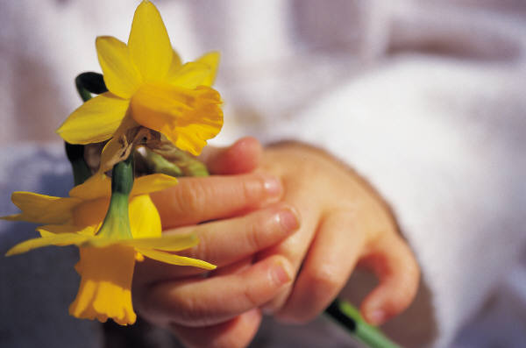

Three Rivers Community College
ECE 176 Health, Safety and Nutrition
Portfolio Assignment

Course Objectives:
- Develop skills necessary to plan and implement health, safety and nutrition experiences and to integrate these experiences into the daily curriculum.
- Become aware of Connecticut State Licensing regulations concerning health and safety in an early childhood center.

Course Outcomes:
- Candidates will analyze the importance of being a continuous and collaborative learner. (NAEYC Standard 6.c)

It is important that when you work with young children that you promote their early understanding of health, safety and nutrition. The most common way we promote this development is through the environment and interactions with children (curriculum). To become a better early care educator you should be prepared with a wide range of resources to use with young children that are age and developmentally appropriate. Be sure to use any resources available to you, including your textbooks, on line, libraries, etc.

For each section, as appropriate, you will need to identify materials for a variety of different aged children (infant, toddler, preschooler, kindergartener and primary school) we will be exploring in class. You may want to include five entries in each section for each topic (5 in health, 5 in safety and 5 in nutrition).You may also chose to focus on a specific age group, targeting the age group you plan to work with in the future, but there should be materials identified as appropriate for a variety of different skills and developmental abilities relevant to that age / grade.

A. Overview
You need to develop a summary of the resources included in the assignment. Your name, intended purpose of this resource and the basic premise you have for the assignment must be included. I want to know what was the direction you used?, challenges?, supports? and overall opinion of the process you went through completing this assignment. This is only a paragraph or two in length.

B. Fifteen quality children’s books
Five for each of the three topic areas (health, safety and nutrition). For each entry you will need to include all the necessary bibliographical information. Please note that you cannot duplicate authors more than once. Remember the key is quality.

You then write a brief narrative for each book that includes:
- the reason you picked this book,
- age group appropriate for and why,
- identification of the specific health, safety and / or nutrition skills the book promotes as appropriate to the specified age group,
- important characteristics of the story and
- possible ways you would introduce and / or use the story with children.

C. Fifteen planning resources
Five for each of the three topic areas (health, safety and nutrition). This section will need to include all the necessary information about the resources you have access to that supports your collecting information about health, safety and / or nutrition for young children. These resources can be places, websites, textbooks, people, etc. But they must be educational in nature and include a wide variety of different resources.
For each resource you will need to include:
- the resource you identified (if a book then include the citation)
- the reason you picked this resource / website / person / etc.,
- a quick overview of the material(s) and a reference to the relevant health, safety and / or nutrition skills it promotes.
- what age group you would use it with and why, and

You should research local, state and national sources and include these, as appropriate, in this section. Your textbook will help you here. Again, be creative and remember the key is quality.

D. Fifteen activities
Five for each of the three topic areas (health, safety and nutrition). These are possible activities (cooking activity, finger play, movement activity, song, materials to explore, etc.) that you would want to do with children to promote health, safety and / or nutrition skills. This section will need to include all the necessary information about the places you collected these ideas from and again they should be different (no duplications) and, as appropriate, cite the source of the activity / curriculum idea.

For each activity you will need to include, as appropriate:
- the curriculum idea or activity,
- the source of the idea,
- a small part or clear explanation of the activity,
- age group it would be appropriate for,
- a quick overview of the purpose of the activity, and
- a reference to the health, safety and / or nutrition skills it promotes.

Be creative, you must include the many different types of ways that children learn as they play. Use the information from section C as possible resources for these activity ideas. You cannot use more than two examples from one resource.

Yes you can use one of these as your lesson being conducted in class!

E. Fifteen Articles
Five for each of the three topic areas (health, safety and nutrition). At the end of the assignment you are asked to include articles regarding health, safety and / or nutrition skills and related information. You need to include a variety of articles (you cannot include articles given in class). Please be sure to consider the many ways articles are useful as they can be used to inform parents, develop new curriculum ideas, research for support with classroom techniques, etc.

You will need to include the actual article or direct link so I can access it online in your paper. For each article you will need to include, as appropriate:
- the source of the article (complete citation),
- who the article would be appropriate for and why,
- a quick overview of the article

ECE 176 Health, Safety and Nutrition
Portfolio Assignment Rubric

 | Highly Competent (3) | Competent (2) | Developing Competencies (1) | Incomplete / Missing
Children’s Books | Included all relevant information about the book in the citation. Identified correctly an appropriate age group as well as the skill being promoted. Description provides detail of the book’s unique features, specific enough to allow for future reference, and showed familiarity with the story. Choices were of high quality as displayed through the exploration of children’s book awards. Utilized a variety of different sources for finding the books. Choices showed an awareness of meeting the needs of a diverse learning population. | Cited reference information, with minor errors. Descriptions include details that identify the reasons why the book was chosen and information about the story. Most selections identified appropriate components as it pertains to the selected age group. Selections were taken from a variety of sources and most were high quality. | Citations were incomplete. Some details are provided about the books but not enough to identify what goals are being addressed. Missing relevant information. Sources weren’t very diverse. | Citations were missing and / or incomplete. Not enough information provided to show awareness of the story. Most books were collected from one source.
Planning  Resources | Included all relevant information about the resource in the citation. Identified correctly the appropriate age group(s) and range of skills that the resource could be used for. Description provides detail of how the resource is useful, included some specific curriculum ideas and showed familiarity with the resource. Choices were of high quality as displayed through the variety of standards identified, specific to state and accreditation requirements. Choices showed an awareness of curriculum development designed for a diverse learning population. Utilized a variety of different sources for finding the resources. | Cited reference information, with minor errors. Descriptions include details that identify the reasons why the resource was chosen and appropriate components as it pertains to the selected age group. Selections were taken from a variety of sources and most were high quality. | Citations were incomplete. Descriptions weren’t clear or didn’t identify the component for curriculum development. Goals weren’t specific to the age group(s) identified. Didn’t include enough information. | Citations were missing and / or incomplete. Not enough information provided to show awareness of curriculum. Health, safety and nutrition weren’t focused on in the selections.
Activities | Included all relevant information about the source of the activity in the citation. Clearly identified specific and diverse goals for children incorporating the wide range of developmental needs of children. Choices were creative, innovative and of high quality as displayed through the variety of developmental domains covered through the curriculum materials. Utilized a variety of different sources for finding the activities. | Cited reference information, with minor errors. Noted and applied some appropriate components as it pertains to the selected age group. Selections were taken from a variety of sources and most were high quality. The range of developmental skills targeted was appropriate. | Citations were incomplete. Choices didn’t reflect the understanding of the different methods of how children learn from diverse experiences. | Didn’t include enough variety or information to meet the curriculum requirement.
 | Highly Competent (3) | Competent (2) | Developing Competencies (1) | Incomplete / Missing
Articles | Included all relevant information about the article in the citation. Choices were of high quality as displayed through the variety of topics identified. Included articles for a wide variety of purposes, including as a practitioner as well as for use with parents. Utilized a variety of different sources for finding the articles. | Formatting of the citation was appropriate. Choices included a variety of relevant topics and could be used with a variety of populations. Utilized a variety of different sources for finding the articles. | Citations were incomplete. Articles were outdated, inappropriate or showed a lack of understanding of developmentally appropriate practices. | Provided a limited number of articles, many were missing citations.
Formatting | Well organized, submitted on time and was well written without any grammatical errors. Neatly typed, interesting presentation. The overview was complete. Utilized correct MLA / APA citation format. Included electronic links that could be accessed easily. | Assignment was turned in on time, had some minor grammatical errors and was presented in a readable style. Some parts were formatted differently and were missing some information. | Assignment was incomplete and had some grammatical errors. Missing critical information and some relevant details. Format was difficult to follow. | Assignment was incomplete, had numerous grammatical errors and wasn’t formatted correctly.
Total points (out of 25)

Three Rivers Community College
ECE K176 Health, Safety and Nutrition
Presentation

Course Objectives:
- Acquire knowledge concerning health, safety and nutrition issues in early childhood classroom environments.
- Become aware of Connecticut State Licensing regulations concerning health and safety in an early childhood center.

Course Outcomes:
- Candidates will know and understand children’s needs as it relates to health, safety and nutrition. (NAEYC Standard 1.a)
- Candidates will analyze the importance of being a continuous and collaborative learner. (NAEYC Standard 6.c)
- Candidates will understand the state licensing regulations and the role each individual plays in meeting these standards. (NAEYC Standard 6.a)

Assignment Requirements:

Each student is expected to choose and research a health, safety or nutrition topic. These presentations are designed to align with what we are working on in the textbook and will be assigned.

Answer each question with details utilizing any resources available to you. The more information you give to support your answer the better you will do. Reflect on the topic and focus on the impact licensing and / or the standards have on decisions made by child care providers and / or parents. Be sure that your responses identify that you understand and can apply the diverse materials we have used in this class.

1. What area of health, safety and nutrition did you focus on? Be prepared to give background details along with references to the text.

2. What did you learn about the topic? You must include details from your resources and CT licensing.

3. Why is this important to you?

4. Why is this important to professional caregivers?

5. What impact does licensing have on how children and their families address this topic?

6. Other ideas around the topic/initiative to be considered.

Presentation Requirements:

There are two main reasons for making in-class presentations: sharing what you have learned with your classmates for their educational benefit, and equipping you to make strong and effective presentations to others in the “real world” when you need to. Look at these presentations as a way to build and improve your skills while giving you practice in sharing ideas and making the case for your opinions.

You will be presenting your information to the class in a visual format (usually a power point) that should last between 20 - 25 minutes. You will share your information with your peers. A basic rule is NOT to read your paper, deliver your comments in a more conversational presentation style. Fill the room with your voice and your knowledge. Be prepared to answer questions (and it is absolutely appropriate to say ‘I don’t know’) and go beyond what is in your presentation.

Three Rivers Community College
ECE K176 Health, Safety and Nutrition
Presentation Rubric

Criteria | Highly Competent  (3 points) | Competent  (2 points) | Developing  Competencies  (1 point) | Incomplete /  Missing
Presentation (adhered to the 20 - 25 minutes as assigned)

Presentation (included visual aid(s) and presented information in a clear format)

Presentation (responded to student questions)

Provided a detailed overview / summary and / related data

Included the reason / why this information is important to educators

Included recommendations for children and families

Opinions were supported by contextual information and details

Expressed enthusiasm for activity

Total Points (out of 24)

Three Rivers Community College
ECE 176 Health, Safety and Nutrition
Lessons

Objectives:
- Develop skills necessary to plan and implement health, safety and nutrition experiences and to integrate these experiences into the daily curriculum.

Outcomes:
- Candidates will know and understand children’s needs as it relates to health, safety and nutrition. (NAEYC Standard 1.a)
- Candidates will recognize the importance of engaging diverse families to support their role and build relationships. (NAEYC Standard 2.a and 2.c)
- Candidates will analyze the importance of being a continuous and collaborative learner. (NAEYC Standard 6.c)

When working with young children you will be asked to develop a written plan that identifies what you plan to do with children. The format and expectations will vary from one center to another as well as from one age group to another. In many of the ECE courses here at TRCC you will be asked to develop either a learning experience plan (for children birth through first grade) or a lesson plan (children who attend kindergarten through third grade) as a preparation for this part of teaching young children. This activity is to give you some prior experience in planning for young children.

You are expected to complete one lesson plan, covering one of the three focus areas (health, safety or nutrition). The concept(s) being taught are up to you but keep in mind the age group, setting, developmentally appropriate practices and the impact the entire environment (inside and out) has on learning about health, safety and nutrition. Some of the key parts of this lesson are as follows:

Lesson Plan Overview, Procedures and Objectives

Title of Lesson: Develop a catchy title that best describes your activity.

Age Group: Identify your setting and age group of children your activity is geared towards.

Set Up / Preparation:
You will be provided a short time period prior to the lesson to set up the experience. Consider where we should be in the room and what you will be expecting from us. YES we are doing the activity you have planned.

Learner Background:
The learner background refers to prior knowledge. Ask yourself, “What would a child need to know to participate in this activity. The “know” could be multilayered and encompass academics, social, emotional, physical, and attention. Describe the students’ prior knowledge or skill related to the learning objective(s) and the content of this lesson. This needs to be accurate and detailed and must be DAP. You need to include connections to families and / or the community as the role the family plays in health, safety and nutrition is integral to the child.

When you are conducting your lesson you will include a statement about what we have already learned / know. Build connections to families and/or the community.

Assessment:
Assessment is an evaluation and means to measure what someone has learned. There are many ways to assess, and equally as many assessment tools. Assessments can be formal or informal, qualitative (narrative), and quantitative (numerical) in nature, and commercial or teacher created tools. How will you ask students to demonstrate mastery of the student learning objective(s)?

As part of your lesson you will need to evaluate what we have been taught. Be creative and again remember DAP!

Materials/Resources:
Identify the materials you will use in the activity including any technological resources. You will need to provide some of the materials necessary for your lesson for us to use (you will have access to materials in the classroom) but, as appropriate, you may reference the additional materials you may want to have. It is easier to simply list these materials – sometimes it may work to show photos of the materials to be used – especially if they are not typical classroom supplies e.g. corn husks vs. pipe cleaners.

Resources may include websites, school resident experts on certain topics or community resources that others can easily access. The list must be detailed, DAP and relevant to the objectives of the lesson.

Learning Activities and Development:
Initiation:

You need to include a transition idea that moves us into the lesson. Briefly describe how you will initiate the lesson. What will draw children to be intrigued, excited or “hooked?” Sometimes it can be an object, a sound or a challenge. For example, to refer to an earlier reference, you could bring in an array of hay, a few sticks and a brick to your group time or provocation table to build curiosity. This activity should raise anticipation, activate curiosity, and encourage imagination. This should build on the family and / or community connections.

Lesson Development:

Conduct the lesson (in part or as a whole experience). This is the part of the lesson that reads like a cookbook – first this, then this. We should know what is expected of us, you should be conducting the lesson as if we are your students but also provide narrative information that identifies what else you would expect. There should be a logical progression that is consistent with the objectives, which expands prior and new knowledge to understanding.

Closure:
Wrap up the lesson so that we have a sense of closure. Briefly describe how you will close the lesson and help students understand the intent. You may include directions as to if you are going to have the children “regroup” e.g. “Come back to the circle from your workspace so we can finish up…” Sometimes this maybe the time to begin the assessment, or if you have other steps to this lesson, you may summarize what comes next. The students should be able to feel some sense of ending through this process – children need beginnings, middles and ends. Ideally, children will be given the opportunity to see the lesson’s progression through technology e.g. short video or photos from hand held devises or to hear their voices and reactions through voice memos.

Three Rivers Community College
ECE 176 Health, Safety and Nutrition
Lesson Rubric

 | Highly Competent  (3 points) | Competent  (2 points) | Developing  Competencies  (1 point) | Incomplete /  Missing
Planning and Preparation
Developmentally Appropriate lesson that reflected and built off of prior knowledge and lessons.

Materials were relevant and were integral to the experience and assessment.

Transitions to and from the lesson promoted interest and next steps. Built enthusiasm for the experience.

Lesson Development

Total Points (out of 15)

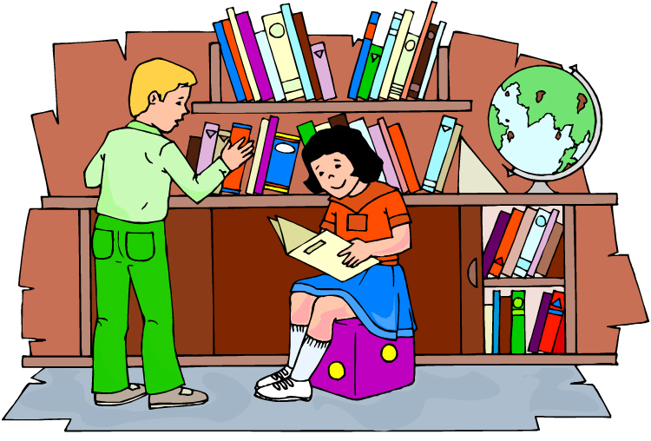

Chapter Notes

Chapter 1 A Holistic Environmental Approach to Wellness
This chapter focuses on wellness and the interrelationships of health, safety, and nutrition in the care of young children. A holistic approach and an ecological perspective allow the teacher to view the total environment of the child. Efforts at the national, state, and local levels concerning health, safety, and nutrition help to clarify the role of the teacher.

After reading this chapter, you should be able to do the following:
- Define a holistic approach to the safety, nutrition, and health of children.
- Describe and discuss the differences between health promotion, protection, and disease prevention as they apply to early childhood education environments.
- Define risk and discuss how risk management is crucial to the safety, nutrition, and health of children in early childhood education environments.
- Discuss how a teacher can provide high-quality early childhood education for safety, nutrition, and health.

Chapter 2 Creating Safe Environments
This chapter discusses how safety policies that manage risk and prevent injury help to maintain the safety level of the early childhood education environment. Teachers should be aware of the environmental hazards, such as accessories, behaviors, and conditions, as they are applied to their early childhood education environments. Teachers should understand and recognize how developmental levels and physical abilities or disabilities affect the safety of children.

After reading this chapter, you should be able to do the following:
- Discuss the importance of safe environments and describe a safe environment for all types of early childhood education.
- Discuss the factors involved in childhood injury and describe strategies for use in injury prevention.
- Explain the development of a safety plan for an early childhood education environment.
- Describe the importance of and strategies for education, supervision, working with families, and observation for maintaining a safe environment.

Chapter 3 Indoor Safety
There are a number of threats to indoor safety, including indoor equipment, toys, interpersonal behaviors, poisons, fires and burns. Safety policies are necessary for teachers to monitor and protect the environment. An understanding of the developmental levels of children present is essential. Teachers should use checklists to monitor and modify the early childhood education environment. All items, including cleaning supplies, pets, computers, plants, and art supplies should be examined for safety and removed if they present risk. Through the use of observation, supervision, education, and working with families, teachers can promote and practice safe behaviors in the early education environment.

After reading this chapter, you should be able to do the following:
- Describe and discuss safety policies for indoor environments as tools for risk prevention, protection, and promotion.
- Relate and discuss the safety hazards of indoor equipment in early childhood education environments.
- Describe and discuss the importance of safe, risk-free toys for infants, toddlers, and preschoolers.
- Indicate the methods and means of poison control and risk prevention in early childhood education environments.
- Describe and discuss methods for engaging families and building curriculum for children in regards to indoor safety.

Chapter 4 Outdoor Safety
This chapter deals with the risks in the outdoor environment. Risks can come from playgrounds, backyards, streets, automobiles, and water. Teachers should learn to monitor the outdoor environment and make modifications using safety checklists and safety devices that protect children in early childhood education environments.

After reading this chapter, you should be able to do the following:
- Describe and discuss safety policies for outdoor environments as tools for risk prevention, safety protection, and safety promotion.
- Indicate and discuss specific guidelines for making the early childhood education playground environment free from risk and protected for safety.
- Relate and discuss the safety hazards of outdoor equipment as they relate to early childhood education situations and general safety.

Chapter 5 Emergency Response Procedures
This chapter covers emergency response procedures needed for the early childhood education environment. It helps the teacher learn to define an emergency and what necessitates first aid. The steps for addressing proper response order and how it is to be performed are given.

After reading this chapter, you should be able to do the following:
- Describe and discuss safety policies for response to childhood accidents and injuries.
- Define and discuss the differences between what constitutes an emergency and what necessitates only basic first aid.
- Indicate the steps to go through in addressing the proper responses to a real emergency and how it is to be performed.
- Define, discuss, and summarize the basic methods of disaster preparedness for early childhood education environments.
- Indicate the need for engaging diverse families and building curriculum for children in regards to basic response procedures for childhood injuries and accidents.

Chapter 6 Basic Nutrition
This chapter considers the importance of nutritional knowledge for teachers. An increasing number of children rely on teachers to provide a good portion of their nutritional needs. Nutritional policies should be created for early childhood education environments that include the use of nutritional guidelines.

After reading this chapter, you should be able to do the following:
- Define and discuss basic nutrition policies and their use for the nutritional well-being of children.
- Describe the importance of the Dietary Guidelines for Americans, the MyPlate Food System, Daily Recommended Intakes, and other information sources that provide guidelines for nutritional well-being.
- Indicate the need for engaging diverse families and building curriculum for children for to better understand proper nutrition to promote health and well-being.

Chapter 7 Protecting Good Nutrition and Wellness
This chapter looks at nutritional challenges that may pose risks to children and affect the early childhood education environment. Nutritional policies should consider the risks for hunger and malnutrition, obesity and the factors surrounding it, and lack of physical activity and exercise. Teachers should have a basic awareness of these risks and how they can help children in their environment by engaging diverse families employing cultural competence and other strategies and building curriculum for children that will keep them nutritionally well and physically fit.
After reading this chapter, you should be able to do the following:
- Define and discuss the nutritional challenges that pose risks for children in the early childhood education environment and the creation of policies to address these risks.
- Define and discuss nutrition in regard to the challenges of hunger and malnutrition as they apply to children in early childhood education.
- Define and discuss childhood overweight and obesity in regard to the impact it may have on the provision of food to children in the early childhood education environment.
- Define and discuss the importance of including physical activity and exercise as part of the diet in early childhood education environments.
- Indicate the need for engaging families and building curriculum for children for proper nutrition to protect health and well-being.

Chapter 8 Providing Good Nutrition for Diverse Children
This chapter shows teachers how to practice good nutrition and develop nutritional policies for different age groups, including infants, toddlers, preschoolers, and school-age children. Teachers need to be aware of how they approach nutrition from their own perspective. Some children with disabilities or chronic illnesses may have to be accommodated, whereas others may need nutritional services beyond early childhood education.
After reading this chapter, you should be able to do the following:
- Define and discuss the need for nutrition policies that address growth and development to prevent risk, provide protection, and promote nutritional well-being.
- Discuss breastfeeding, bottle feeding, and the introduction of solids into the infant’s diet, including developmental implications and practices for the teacher.
- Discuss the impact of development on the feeding behavior of the toddler and describe strategies for the teacher to redirect that behavior.
- Discuss the food behaviors of the preschooler and the strategies for the teacher to guide the child to behaviors that foster well-being.
- Discuss the nutritional needs of the school-aged child and the strategies for the teacher to meet these needs that may be compromised by outside influences.
- Explain how disabilities and other special needs might affect the nutrition and feeding of a child and discuss specific strategies to meet the child’s nutritional challenges.
- Describe and discuss methods for education, supervision, role modeling, and working with families to ensure good nutrition for children in early childhood education environments.

Chapter 9 Menu Planning and Food Safety
This chapter prepares the teacher for planning menus and preparing for food safety. It also helps the teacher to be aware of food programs that can be accessed by early childhood education environments. Teachers will learn how to select healthy foods, plan adequate menus, and prepare food in a safe manner.

After reading this chapter, you should be able to do the following:
- Define and discuss nutritional policies in relation to menu planning and food safety in the early childhood education environment.
- Discuss the guidelines for subsidized food programs available for early childhood education environments.
- Indicate the importance of proper menu planning for children’s well-being, including strategies for planning healthy breakfasts, snacks, and lunches.
- Summarize the need for food sanitation and safety and practice strategies for providing it in the early childhood education environment.
- Relate the strategies for providing safety and healthy meals in early education environments through education, observation, cultural competency, supervision, and working with families.

Chapter 10 Tools for Promoting Good Health
This chapter focuses on health policies needed for early childhood education. Health policies help teachers manage the environment for good physical and mental health. These policies should reflect high-quality early childhood education.

After reading this chapter, you should be able to do the following:
- Define and discuss health policies and their use as a tool for health prevention, protection, and promotion.
- Discuss the contents and importance of health records, including up-to-date immunizations.
- Discuss the importance of health policies for staff, including staff health records and promoting staff health.
- Relate the importance of education, observation, working with families, and the use of appraisals, screening, and assessment to promote good health in children in early education environments.

Chapter 11 Prevention of Illness through Infection Control
This chapter deals with health policies for infection control to maintain health and prevent some illnesses present in the early childhood education environment. Two practices that contribute to this are good hygiene and sanitary practices. Checking the immunization schedule is another preventive practice.

After reading this chapter, you should be able to do the following:
- Define and discuss health for the prevention of childhood infectious diseases.
- Explain the mechanisms of communicable disease spread.
- Describe the importance of education, supervision, working with families, and role modeling.

Chapter 12 Promoting Wellness through Supportive Health Care
This chapter focuses on what teachers need to do to prevent disease spread and how they should care for mildly ill children. Teachers need to form exclusion policies and understand reporting procedures. They need to determine whether they are able to care for children who become ill but are not contagious.

After reading this chapter, you should be able to do the following:
- Describe and discuss health policies for the identification and management of childhood communicable diseases.
- Describe the methods and practices for managing childhood infectious diseases for early identification and prevention of disease spread.
- Indicate the need and importance of education, observation, supervision and working with families for early intervention to manage childhood communicable diseases in the early childhood education environment.
Chapter 13 Providing for Special Health Care Needs
This chapter focuses on children with chronic health conditions who may be in the early childhood education environment. Teachers need to use a holistic approach as they work with children who may have a chronic health condition that requires extra vigilance. They can use different strategies to help manage the chronic health condition present.
After reading this chapter, you should be able to do the following:
- Define and discuss health policies in relation to caring for chronically ill children or other children with special health care needs in the early childhood education environment.
- Describe and discuss the inclusion of a health consultant in the early childhood education program and the advantages of having a medical home for every child.
- Indicate the need for and importance of engaging families for early intervention to manage childhood communicable diseases and to build curriculum for children to help them better understand and support others in the early childhood education environment who may have chronic health conditions.

Chapter 14 Child Maltreatment
This chapter helps to raise the awareness of the teachers about child maltreatment and how it affects 3.6 million children every year in the United States. Teachers are provided preventive and protective measures that help ensure the children in the early childhood education environment the greatest level of protection. Policies should be created to help the teachers deal with child maltreatment.

After reading this chapter, you should be able to do the following:
- Define and discuss the need for policies for child abuse and neglect that may affect the early childhood education environment.
- Describe and discuss how to recognize, document, and report child maltreatment, and methods for caring for an abused child.
- Describe and discuss the importance of engaging families and building curriculum for children on the sensitive topic of child maltreatment.

Chapter 15 Fostering Good Mental Health and Emotional Well-Being
Mental health is an area of health promotion that may be overlooked. About 10% of children are at risk for mental health difficulties. Early childhood mental health is related to a child’s wellbeing in relation to social and emotional development and emotional well-being may be at risk due to societal forces that affect their families.

After reading this chapter, you should be able to do the following:
- Define and discuss policies for mental health policies and their place protecting the mental health and emotional well-being of children.
- Describe the factors that may cause stress to children and how to help alleviate that stress in the early childhood setting.
- Indicate the importance that stable, responsive, and consistent caregiving and good communication has on providing children with an optimum environment for good mental health.
- Describe strategies for engaging families and helping children through communication, role modeling, and building curriculum to provide the best possible environment.

Articles and
Review Questions

Brain Development in Children
Brain development in children happens gradually and every area of their brain begins to function efficiently with time. This article will cover all the aspects related to their early brain development.

Brain, the commander-in-chief of our body. The human body cannot function without the brain. Our body may remain alive with the heart being pumped artificially, but it won't be able to bat an eyelid, if the brain stops working. We are all born with a brain that is almost developed. There are many wires and connections within the brain that are connected and functional only during the infancy and toddler age. The brain development occurs due to the genes and environment of the growing child. The inherited gift (genes) of the child makes the structure of the brain possible, but it is the healthy diet and external stimulation of the surroundings that gets the brain connected in the most efficient way.
The ability of an infant to be able to speak, crawl, cry, laugh, walk, recognize, remember, etc., all is nothing short of a miracle. The brain is able to develop due to the interactions and the care provided by the parents. The simple gaze a mother gives her baby while feeding, the lullaby sung by a caring father, etc. form a stepping stone for the early brain development of a child.
Thus, not only the genetics and nourishment play a part in the development of our brain, but the daily interactions, physical activity, love and daily experiences help the brain development in early childhood. The brain develops with the help of the external factors of the surroundings. The five senses of vision, hearing, smell, taste and touch help in developing an unconnected brain structure. The child learns to recognize the faces of family members, the voice of his/her father, the smell of his/her mother's skin, the taste of the milk he/she drinks and the gentle caressing of his/her grandmother. This helps the brain get wired up accordingly and have an impact on the basic architecture of his/her brain.
There are over 100,000,000,000 cells in the brain when a child is born. These cells need to start communicating with each other and during the miraculous changes, the brain follows the Darwinian theory of selection of the fittest. In other words, those synapses and connections that are seldom used by the child are deleted and those that are useful are developed further.
The prime time for the child to learn and understand concepts that will prove helpful throughout life are the early formative years. The brain of a 3 years old is two times more active than an adult. Thus, it is very important to encourage the various interactive activities that will help in brain development. The types of brain development in early childhood are:
http://www.buzzle.com/articles/brain-development-in-children.html 8/14/2012
Cognitive Development
Brain Development in Children Page 2 of 6

- Development of the Visual and Auditory Senses: The vision and hearing senses are the first to be developed in children. To improve these senses the parents and guardians should ensure the child is exposed to different colors, shapes, and sounds. You can hang different vividly colored and shaped chimes over the child's cradle that have a visual appeal and a soft rhythmic sound that will help develop the child's vision and auditory senses.
- Development of Language Skills: The child begins to gurgle some sounds and moves on to some monosyllables like ma, pa, da-da, etc. The parents should develop these speech skills by talking to the child and encouraging him to speak. Reading out poems aloud and singing songs and lullabies help in the process. Although the infant may not understand their meanings, but will be able to grasp the different sounds of the words, registering them in his brain for future reference.
- Development of the Motor Skills: The child's brain begins to gain control of the muscles. The child starts moving his arms and legs in all directions playfully and this is part of his physical exercise and development of motor skills. The child begins to hold fingers and grasp toys, thus helping in his fine motor skills of the hands, fingers, toes and feet. The parents should help the child with physical activities that will help in the physical development of the body and the brain.
- Development of the Emotional and Social Quotient: The healthy, warm, caring and loving environment the child receives, plays an important role in the development of the child's emotional and social skills. It is very important for the parents to maintain a healthy environment in the house, as the child is very vulnerable to negative emotions around him. The child develops emotions of hatred, anger, fear, etc. as easily as love, trust and empathy by learning from his surroundings. Thus, provide the child with ample positive emotions and social skills that will help him adjust into the society easily.
How does the Brain Learn After Birth
The most common advice new parents are given is to cradle their baby's head very carefully. This is because the neck muscles cannot support the weight of the head. The brain is already one-fourth the
weight of an adult's and the prenatal phase is when the neurons, axons and synapses form and connect. Let us see how the child goes through different milestones of growth.
http://www.buzzle.com/articles/brain-development-in-children.html 8/14/2012
Development During Early 6 Weeks
Brain Development in Children Page 3 of 6
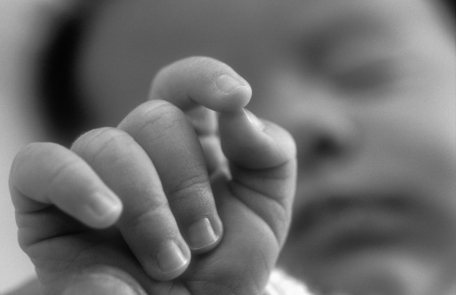

A newborn is totally dependent on the mother for its basic needs. The first 6 weeks is the time when they learn many things and form a bond with their mother and others. The baby pays close, very close attention to the surroundings and thus, make sure you treat him/her well. During this time the baby:
Can See: objects that are just 8 to 12 inches away. This means it can see the mother's face only when she holds him close to her body. Very soon the baby's vision will improve and you will observe him/her following all your movements. This is the time when the baby enjoys looking at bright, colorful as well as black and white images and objects.
Can Hear: voices and sounds around it. The baby could hear when it was inside the womb of its mother. Thus, the minute it is born, it recognizes its mother's voice instantly.
Can Feel: Touch is one important sensation that babies can understand. It is a way to build trust and bond with your baby. Give the baby gentle messages, hold him/her close as a way to make the baby believe loved and secure. Make sure your dress the baby appropriately with clothes that suit the weather. As babies are sensitive to temperature fluctuations.
Can Communicate: Crying, gargling, cooing are all forms of communication for the baby. When the baby feels hungry, tired, sleepy or is in pain, it will cry. When the baby wants talk to you, it will start cooing.

Development During 3 to 6 Months
http://www.buzzle.com/articles/brain-development-in-children.html 8/14/2012

At this age, the baby turns more social and will start playing simple games with parents. The baby realizes that its actions tend to stimulate its surroundings. Muscle control is better and thus, the child will try to explore the world around it. During this time, the baby:
Can See: as far as 3 feet. It will follow objects across, over or under him/her visually. The baby starts developing depth and distance perception, that is, can understand objects placed far away and near to him/her.
Can Eat: This is the best time to introduce them to solid foods after consulting with the doctor. The child should be made to sit upright, before feeding any solid food. These foods should be iron-fortified, single-grained, or baby vegetables.
Can Move: The baby starts to roll over, sit up with the help of support as well as learn to grab things. The baby starts playing with its hands and can reach for his/her toes. It begins to put things in its mouth and learn to explore the toys.
Can Communicate: The baby starts producing more sounds, vowels and starts to squeal. The facial expressions are more pronounced and may even gurgle when having a conversation. The child develops emotionally and starts reacting in a different manner when hearing the voice of a familiar person and a stranger.
Brain Development in Children Page 4 of 6

Development During 1 to 2 Years
This is the phase when the child learns to walk and talk. Thus, the child needs to be supervised at all times during this phase. The toddler during this phase:
Can Eat: with the family 3 times a day. The appetite may decrease during this time and toddler will favor one type of food.
Can Move: The toddler learn to walk on its own. He/she will also learn to kick a ball and learn to climb stairs. The baby starts using its finger and learn to hold on to things like a spoon. This is the time when they love to draw and color. Make sure you provide the child toys to stack up, rings that fit in one another and simple puzzles to develop fine motor skills.
Can Communicate: This is the time when vocabulary increases. The child will use words when he/she recognizes certain objects in books or pictures. The pronunciation may not be correct, but encourage the child to speak more.
http://www.buzzle.com/articles/brain-development-in-children.html 8/14/2012
These were a few development milestones that occur during the child's growth phase. Let us now have a look at the milestones that happen within the brain according to the child's age.
Brain Development in Early Childhood
There are certain milestones that are achieved within the brain according to the age of the child. Let us see the different stages of child development according to age:
Brain Development in Children Page 5 of 6

Development Milestones of Brain
- Age 4 Months: The brain starts responding to the different words or sounds produced in any language spoken.
- Age 8 to 9 Months: The infants brain begins to develop memory as they experience different activities like pushing a ball around or throwing a spoon.
- Age 10 Months: The child begins to focus on his own new language like ma, pa, da-da, ba-ba, etc. and pays little attention to the other languages spoken around him.
- Age 12 Months: The child begins to respond to words that are spoken in a child-like funny manner than flat, normal voices. For example, when the mother says, 'shee the moo-moo' the baby will look towards the cow more often than when he hears, 'see the cow'. Thus, it is often said a child should be spoken to in the language he understands.
- Age 12 to 18 Months: Babies and toddlers begin to explore their memories and carry out the forgotten activity. If the child seen a toy that needs winding up, the child will wind it till it finally begins to play.
- Age 24 Months: The toddler and preschoolers recognize the people around them and know their friends from strangers. They begin to cry when handled by people who are unknown to them.
- Age 30 Months: The child begins to develop a kind of map in his or her mind and knows, where the things are in his or her surroundings.
- Age 36 Months: The child begins to show two different emotions at one single time, like falling down while playing and feel like crying, but happy that he is having fun playing in the park.
http://www.buzzle.com/articles/brain-development-in-children.html 8/14/2012
The child's mental ability develops with specific types of learning. There are certain critical periods that help him absorb particular information at a faster rate. For example:
Brain Development in Children Page 6 of 6
- Emotional Intelligence: The optimum period for development of the brain is 0 to 24 months and the next best age is 2-5 years. The EQ can further develop at any age.
- Motor Development: The optimum period is 0 to 24 years and then 2-5 years with the possibility of further development possibility decreasing with age.
- Vision: The optimum period of vision development is 0 to 2 years and then 2 to 5 years. The vision may remain constant or decrease with age.
- Hearing: 4 to 8 months is the optimum age period for development of early sounds. Then 8 months to 5 years is the next best age. The ability to recognize and understand sounds keeps developing with age.
- Ability to Think: The child begins to think from 0 to 48 months. Then the next best age period is 4 to 10 years when parents and other adults are bombarded with a million questions. This is the age when the child is actively thinking and questioning the happenings of the surroundings.
- Second Language Skills: The child can learn and understand a second language other than his mother tongue during 5 to 10 years of age. The child can further learn more language skills at any age.
The best way to influence the brain development is by contributing towards an active interaction with your child. You should, sing, talk, read and explain simple things to the child to help him develop his brains. The brain of a child is rightly called a plastic mold that can be shaped as the parents mold it. It is like a blank page and how well you write the script of knowledge, grasping power and emotional expressions on it is up to the parents and caregivers. You should provide ample opportunities to the child to help him develop his brain and flourish accordingly.
A warm home, loving family and good educational development will ensure a steady brain development in kids. No two children are alike. Thus, some may learn quickly or some may take time. Do not give up on any child, if he does not act according to your expectations. It is not about your wants, but the child's dreams. Let children learn at their own pace by always being there with a supportive hand. Just as Einstein took time to find his niche, you never know your child may take time to find his path. Encourage the brain development in early childhood with love and attention.

By Batul Nafisa Baxamusa
Last Updated: 2/18/2012

Three Rivers Community College
ECE K176 Health, Safety and Nutrition
Article Review Questions

Throughout this course you will be given many different resources to review as a way to enhance the materials covered in class. You are responsible to read and familiarize yourself with these materials. To help you with this process I have developed some review questions to go along with some of the articles. These questions will need to be handed in and will count as part of your grade (participation). They will not be accepted late as they will be used to promote participation the day they are due.

____. (2011). Brain Development in Children.Buzzle.com.

- What was the main idea of the article? How did this information compare to what you read in the textbook?
- What were some big changes that occur in the brain as the child grows: How can you “see” this and explain it to parents?
- How would you use this information in the future?

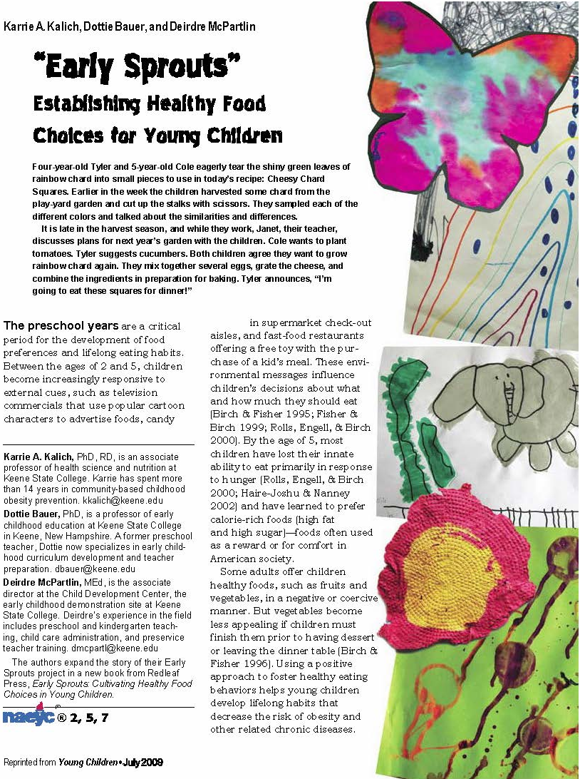
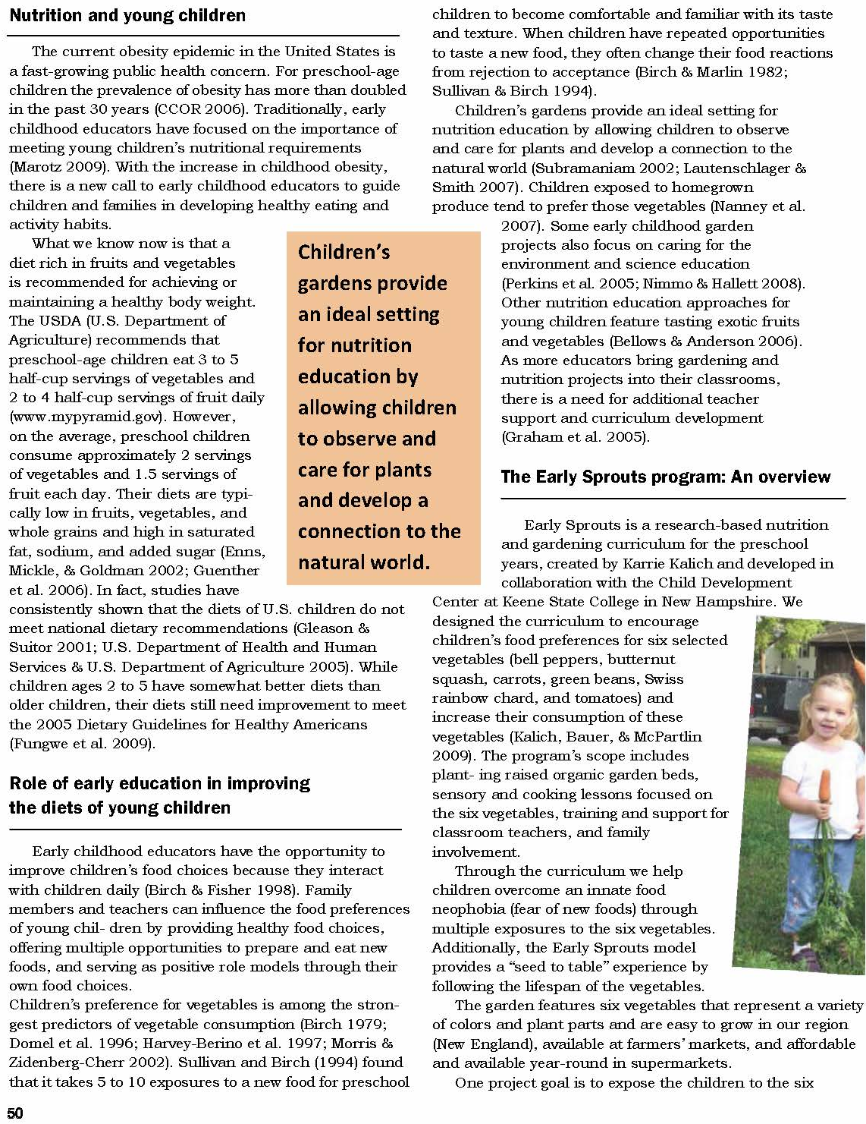
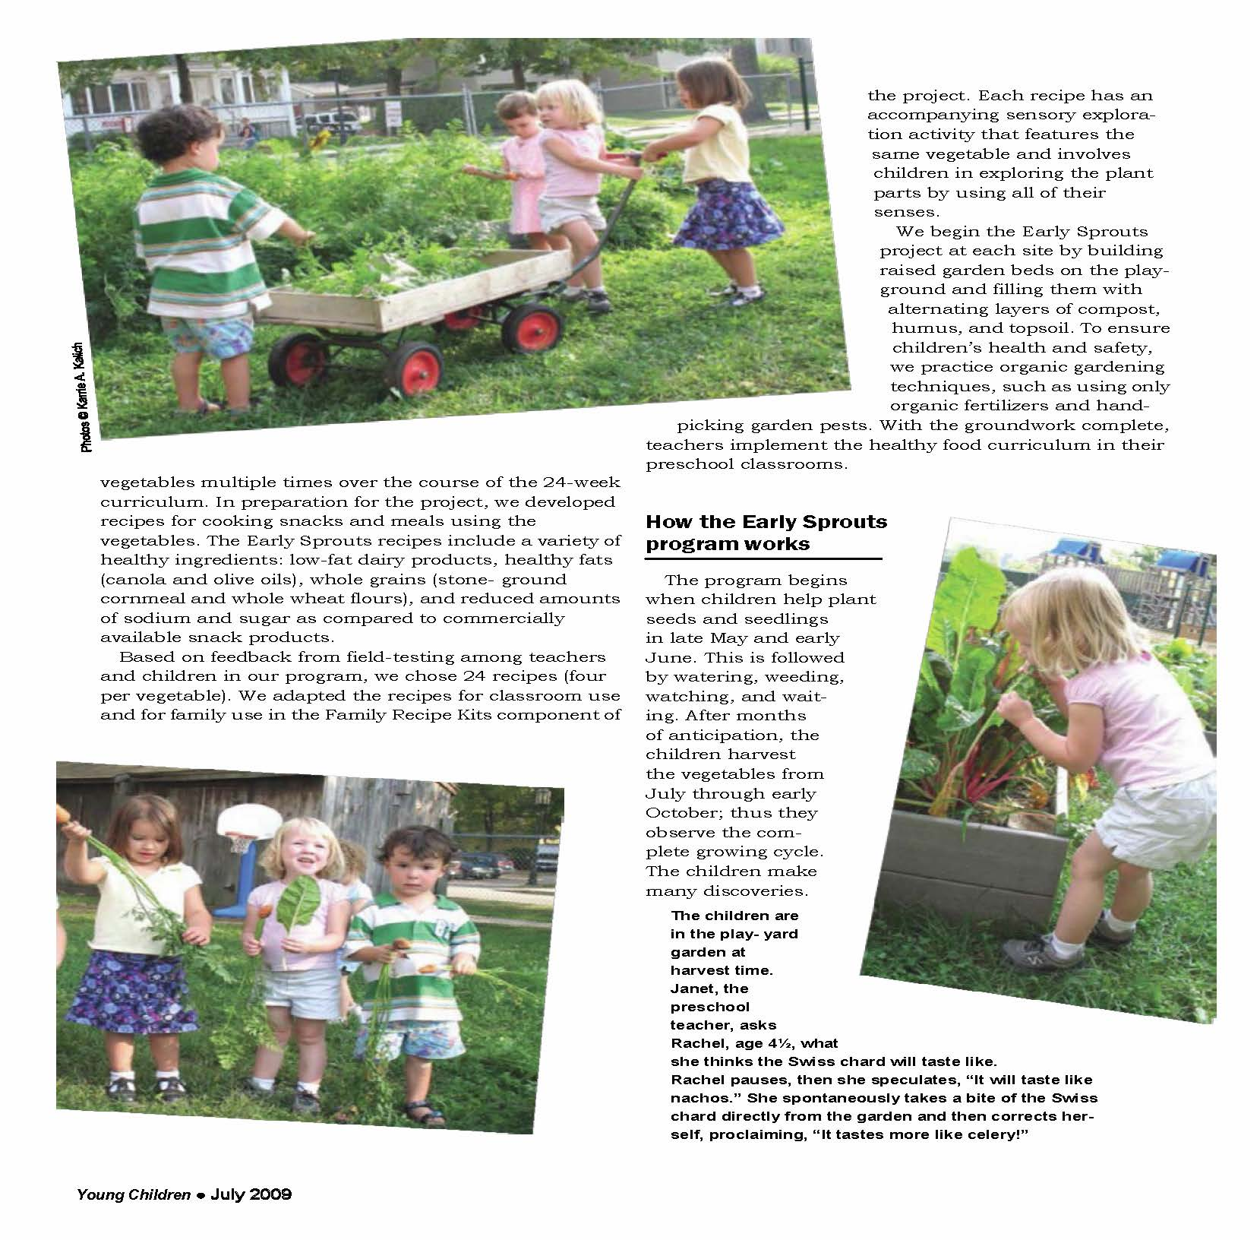
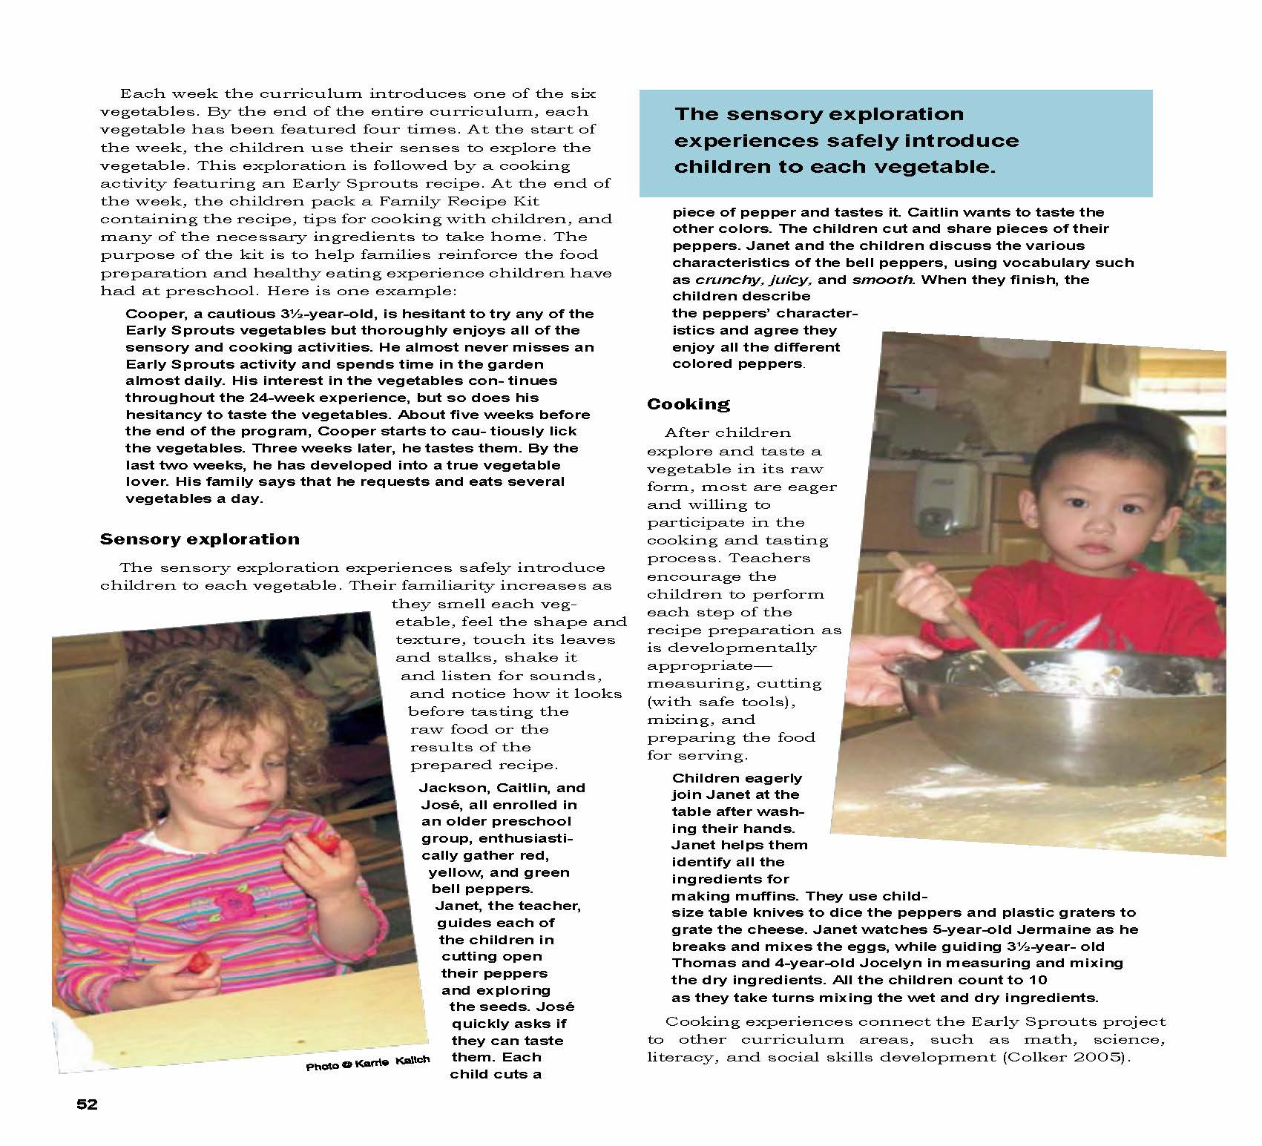
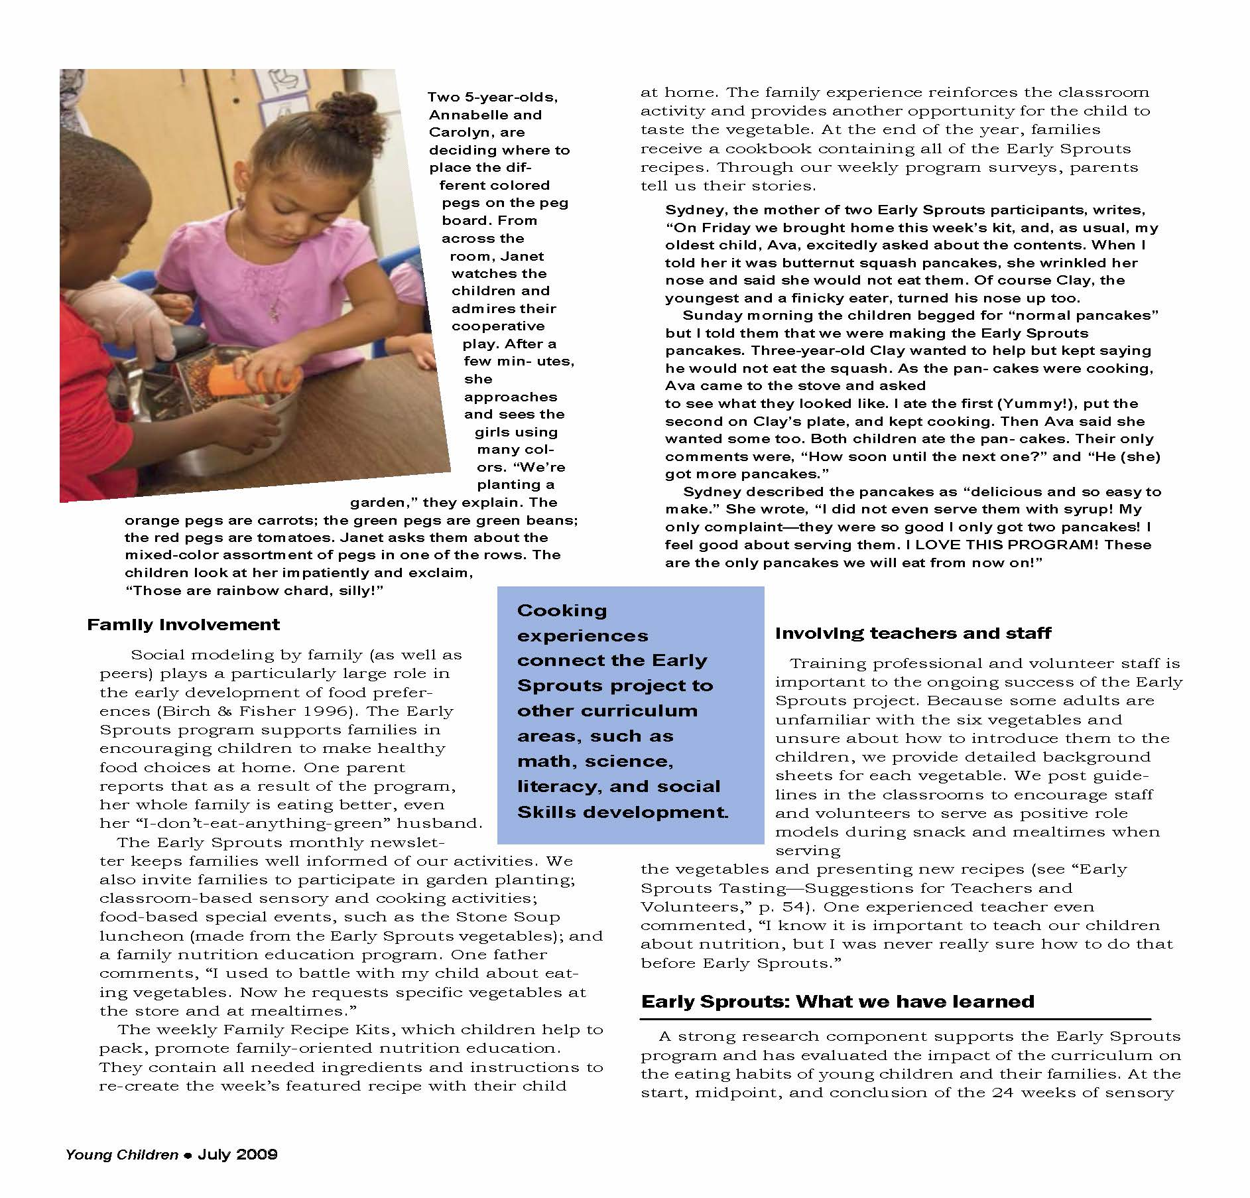
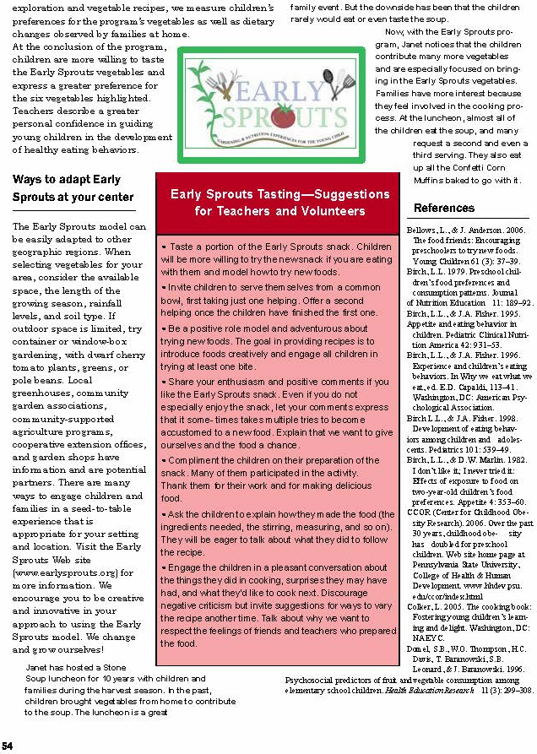
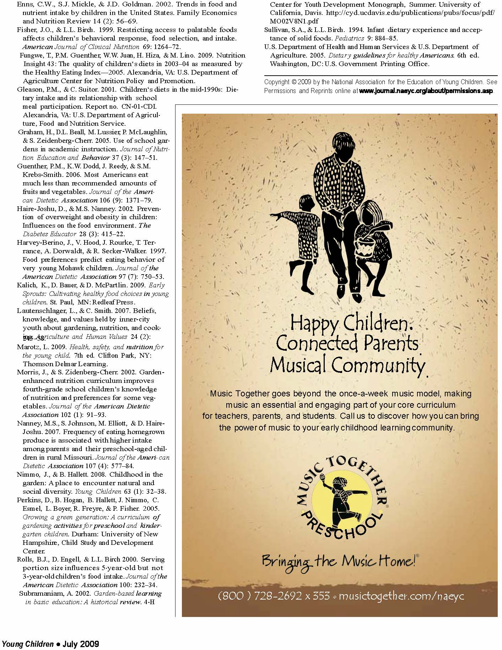

ECE K176 Health, Safety and Nutrition
Article Review Questions

Throughout this course you will be given many different resources to review as a way to enhance the materials covered in class. You are responsible to read and familiarize yourself with these materials. To help you with this process I have developed some review questions to go along with some of the articles. These questions will need to be handed in and will count as part of your grade (participation). They will not be accepted late as they will be used to promote participation the day they are due.

Kalich, K.A., Baure, D. & McPartlin, D. (2009). Early Sprouts: Establishing healthy food choices for young children. Young Children, NAEYC.

- What is the early sprouts program?
- Do you think it is comprehensive enough and can be easily used at other child care centers? Why or why not? Explain.
- What would you add or change about the early sprouts program? Why?

How Mothers In Four American Cultural Groups Shape Infant Learning During Mealtimes
Mary Martini, Ph.D.

University of Hawaii at Manoa
Honolulu, Hawaii
P
arents shape children's learning in many ways (Bruner, 1981; Gauvain, 2000; Rogoff, 1990):
- explaining and demonstrating to children (the parents' understandings of) how the world works;
- directing children to attend to certain culturally valued aspects of reality and to ignore others;
- demonstrating culturally valued "goals for action" or definitions of what a person should want to try to do, say, with an object (i.e., teaching children that bells are for ringing, hammers for hammering , spoons for scooping, instead of for some other goals};
- shaping children's actions to help them achieve and learn these desired actions;
- redirecting children away from performing socially/culturally undesired actions; and
- structuring children's day-to-day lives to expose them to particular people and activities.

To encourage children to take on the same "goals for action" as adults in that culture, parents engage young children in "shared routines" in which they microstructure the child's actions to achieve a particular goal and then praise the children for "intending" to accomplish this action. Bruner gives the example of a mother teaching her infant to ring a bell. The mother first labels the bell, puts the handle in the baby's hand, and wraps his fingers around it. She then holds his hand, shakes the bell, and announces "Oh, you're ringing the bell." After several repetitions of this managed routine, the baby spontaneously grasps and rings bells, rather than, say, sucking on them. He learns to ask for a bell by reaching, grasping the handle, and shaking it himself. Parents speed up the trial and error process needed to discover features of objects, such as the ability of bells to ring, by microstructuring the child's contact with the objects.
Bruner (1981), Bates (1976), and others provide many examples of mothers and infants engaging in games (give-and-take, peek-a-boo, hi-and-bye on phone, etc.) that result in the infants taking on the same goals for action as suggested by their mothers. Bruner commented that parents microstructure their children's goal-directed actions constantly, each day, and that children's intentions or goals for action come to closely resemble those of their parents.

How Do Parents' Cultural Beliefs Influence How They Shape Learning?
Cultural beliefs influence the microstructuring process. In particular, parents’ conceptions of what a good, successful, mature adult is influence their day-to-day efforts to shape their children toward that image. The image of a competent, mature adult differs in some ways from culture to culture. For some time, I have been studying parents from 278 families in Hawaii who belong to four different cultural groups: Filipino­American, Japanese-American, Caucasian-American, and Native Hawaiian. I asked these parents to list the features they most wanted their children to acquire and to imagine that their children were now successful, young adults and to describe the characteristics of these successful adult-children. Parents in these four groups report wanting their children to grow up to be somewhat different "successful adults" (Martini, 2002a):
- Filipino-American parents (n=50) differed significantly from parents in the other three groups in the extent to which they wanted their children to grow up to be obedient, good citizens who respect authority and conduct themselves well, displaying good manners.
- Japanese-American parents (n= 120) most wanted their children to achieve, to live a well-ordered life in contact with family, and to master the demands in their lives.
- Caucasian-American parents (n=60) most wanted their children to become self-reliant, happy, spontaneous, and creative.
- Native Hawaiian parents (n=48) said they most wanted their grown children to be socially connected, happy in their networks, and self-reliant.

How Do Parents Shape Learning at Meals?
Reflecting on the similarities and differences in the aspirations parents from different cultural groups had for their children, I wondered whether -and how- these differences might be reflected in the ways parents shape their children's experience at mealtimes. Parents influence mealtime learning by how they organize mealtimes to: include particular participants; occur in specific settings; take certain amounts of time; and include specific activities, such as eating, feeding, playing, talking, or exploring. Parents highlight valued goals for action, and focus the infant's attention on valued aspects of the setting (for example, on the food, the other people, the activities, etc.). Parents set up and reinforce valued moment-to­ moment routines (where to sit, what to eat, how to eat, how to interact with others at the table, etc.). Parents then microstructure infants' moment-to-moment actions. In doing so, they show their babies how to learn, interact, and think. I was curious to observe variations in how parents from the four cultural groups I have been studying set up and shape mealtime interactions with infants, and to learn how differences in parental behavior might be related to how children come to approach learning in these settings.

A Study of 90 Families' Weekday Evening Meals¹
Using letters to preschools and an elementary school, and through professional and personal contacts, I recruited 90 families from four American cultural groups who had children from 3 to 23 months old. They identified them­selves as identifying most strongly to one of four groups: Japanese-American (26 families); Caucasian-American (23 families); Hawaiian-American (21 families); and Filipino­American (20 families). Parents completed a questionnaire on demographic features of the family and child-rearing beliefs and practices. We lent families video cameras and asked them to videotape "a typical weekday evening meal" with their infants.

The four groups of families were similar in terms of the mean age of the infants (range 11.8-15.1 months) and the ratio of boys to girls. The groups were also statistically similar in terms of whether both parents were present at the evening meal (in 57% to 81% of the families), the average number of siblings present (.5 to l.29), and the average number of other relatives present. We learned that 30% of Caucasian-American families had the TV on during meals, compared to 48% of Filipino­American families. Because we were interested in how infants approached learning in these studies, we selected for further analysis tapes of families with infants who were 7 to 23 months old. We focused on this older age group because we wanted to study infants who were old enough so that their signals and acting upon their intentions would be clearly visible on tape. We found 64 tapes in which we could analyze the infant's stream of behavior.
We focused our analysis of mothers' and infants' behavior on "communicative acts" (Sinclair & Coulthard, 1975). A communicative act is any action by one person directed at another person that can be seen as having a communicative function, such as "asking for information," "asking for help," "commanding," "offering help," "scolding" the other, or encouraging the other to do something. After viewing the tapes repeatedly, we developed systems to code the following:
- features of the mealtime setting (number of people present; which family members are present; whether the family sits at the table, on the floor, in front of the television; whether the baby is in a highchair, on a lap, wandering);
- maternal actions during these feeding and learning interactions (mother responds to infant; mother directs the infant; mother communicates with the infant about her own or the infant's goals or strategies); and
- child actions in the mealtimes (how much the infant explores and experiments, is expressive, engages in play routines with the parents, cooperates, resists, engages in "disruptive" behavior s such as throwing food or screeching).
The middle 10 minutes of each transcript were coded, minute-by-minute, with the coder focusing: 1) first, on the setting features; 2) on maternal behavior, for the second run­through; and 3) on child behavior for the third run-through. An analysis of variance was conducted, comparing setting features, then maternal actions, and then child actions across families in the four cultural groups.

Findings About Mealtimes and Mothers' Styles
Our findings provide answers to six questions.

1. To what degree does the family mealtime revolve around the infant? Infants learn, in part, by interacting with attentive people. To what degree do mealtimes in the four cultural groups enable such attentive interactions?
  - Japanese-American mealtimes were the most infant centered. Many infants in this study were fed before the rest of the family ate, sitting in a highchair or infant seat on the table. Mothers sat face-to-face with the infant and attended solely or primarily to the infant. After feeding the infant and putting him or her down to sleep or play, the Japanese-American mother would eat with and attend fully to older children and the father. Japanese­American fathers were significantly more likely than fathers in the other groups to help mothers feed the baby and care for older children. When Japanese-American babies signaled that they wanted to stop eating or get down, their parents were significantly more likely than parents from other cultural groups in the study to respond positively and quickly to those cues and to let them down.
  - Filipino-American mealtimes were the next most infant centered. These babies, though, tended to be held on the mother's lap at the table, while the whole family ate. Families ate, relatively quietly, as large groups. Older children ate quickly and quietly. Adults tended to talk to each other after the children had eaten and had left the table. The Filipino-American mother attended frequently to the baby on her lap, and spoon-fed infants and toddlers until they were 2 or 3 years of age. The mothers talked to other family members, but dinner appeared to be more for eating than for talking.
  - Hawaiian-American mealtimes were less infant centered than were meals in the other two groups. These meals were occasions in which adults conversed extensively with each other (for example, mothers of infants talking with their own sisters or mothers). Children ate, quietly, on the periphery or in their own peer groups. "Lap" babies (up to about 9 months) were held and fed on laps, but as soon as they could crawl or toddle around safely, they were put down to roam. In many families, one adult held a bowl of food for the roaming toddler and fed him or her whenever the toddler approached. Older siblings helped direct and feed toddlers.
  - Caucasian-American mealtimes appeared to be "for talking." These were the least infant centered, as mothers attended mainly to the fathers and to the verbal, older children. Caucasian-American infants tended to sit in highchairs, to the side of or behind their mothers at the table. Infants "fended for themselves" with finger foods, utensils, and bowls of soft food. Many infants used noisy tactics, such as banging the spoon or squealing, to attract the attention of family members who were talking animatedly throughout the mealtime.

2. How much exploration and experimentation can infants do at mealtime? Infants learn, in part, through exploring spaces and experimenting with objects. Mealtimes of these four groups differed in the degree to which infants could experiment with food, toys, or objects or explore the environment during the meal.
  - Hawaiian-American mealtimes provided babies and toddlers with the most opportunities for exploration. Whenever they wanted the next bite of food, babies and toddlers were free to approach any adults or other children for food, or to go to the specific family member who held the child's bowl. These crawling or toddling children were also free to roam during the meal, exploring toys, people, and spaces.
  - Japanese-American mealtime settings enabled the second most exploration and experimentation. Japanese­American infants were confined in highchairs, but many were provided with numerous toys and were allowed to play with their food and utensils.
  - Caucasian-American babies were confined in high­chairs, and allowed to feed themselves and explore with spoon and fingers, but were generally not provided with toys. Mothers said they worried that toys would distract the infant from eating.
  - During mealtimes in Filipino-American families, infants and toddlers were, for the most part, constrained on laps and not allowed to feed themselves, play with food, get down to explore, or play with objects. Some mothers continued to spoon-feed their 3-year-olds, pushing the toddlers' hands away whenever they tried to feed themselves.

3. How attentive were the mothers to the infants during mealtimes? Socially mediated learning occurs in attentive, responsive, one-to-one interactions. To what extent did such interactions occur in mealtimes in the four groups? To judge attentiveness as we coded the tapes, we calculated the percent of the mothers' communicative acts that had been directed at the infant rather than at other pre­ sent family members.
  - Japanese-American mothers were found to be most attentive. They directed 73% of all their communicative acts toward their babies.
  - Filipino-American mothers directed 62% of their communicative acts toward their infants.
  - Caucasian-American and Native Hawaiian mothers were the least attentive. These mothers spent more time than the other mothers talking with spouses, older children, or other adults at the meal.

4. How responsive were the mothers in different groups? Mothers' communicative acts were coded as "responsive" when the mother responded to infant cues and helped the infant, showed affection, praised the baby, played with the baby, watched the baby carefully, asked questions of the baby, or cared for the baby. Comparing the percent of all communicative acts that were responsive, we found:
  - Japanese-American mothers were the most responsive (45% of all communicative acts were coded responsive) and significantly more responsive than mothers in the other three groups. These mothers were both attentive and responsive. They watched their infants constantly and responded to their cues immediately. Whenever babies signaled their goals, mothers tried to help them if they approved. They subtly redirected infants' actions whenever they headed toward unapproved goals, and then praised infants for complying.
  - Filipino-American mothers were next most responsive.
  - Caucasian-American and Native Hawaiian mothers were the least responsive. Caucasian-American mothers were less attentive to their infants at mealtimes than the Japanese-American and Filipino-American mothers, as they talked frequently with their husbands and older children. They did respond quickly whenever the infant initiated a "goal-directed" action (such as reaching toward what he wanted). Mothers tried to help infants when they signaled needing help, but sometimes infants needed to call quite loudly to receive parental attention.

5. How directive were the mothers in different groups? Mothers' communicative acts were coded as "directive" whenever they tried to persuade the infant to do a particular "mother-desired" action or tried to stop the infant from doing an "undesired" or disruptive action (such as banging her bottle on the tray table, throwing the bottle, dropping Cheerios on the floor, spilling milk, screeching loudly or smearing food on the tray). A mother directed her child when she called for the infant to look at her; requested, suggested, or shaped the infant to do something; or directed, commanded, scolded, corrected, threatened, stopped, punished, or refused to help an infant who was trying to do something.
  - Filipino-American mothers, who were as attentive as Japanese-American mothers, were significantly more directive than mothers in the other three groups. They constrained infants in their laps or in highchairs and watched them carefully. They shaped infants to do particular actions and noticed -and quickly stopped, scolded, and redirected - infants who attempted undesired actions.
  - Japanese-American and Hawaiian-American mothers were in the mid-range of directiveness. Japanese­ American mothers subtly redirected their infants when they headed for undesired behavior. For example, a 14-month-old feeding himself with a spoon began to dollop oatmeal out onto the highchair tray. The mother quietly placed a bowl between his spoon and tray and turned this into a game of spooning the oatmeal into the bowl. She praised him for being so grown up. Hawaiian-American mother allowed children to learn by trial and error as they toddled around on their own during meals. Mothers stopped children only if their actions disrupted the group or endangered the children's own safety.

6. How expressive were the mothers in different groups? A third aspect of maternal style was their expressiveness. Mothers' communicative acts were coded as "expressive" whenever the mother expressed her wishes or plans, interpreted or talked about the infant's or her own actions, or announced what she would do next.
  - Caucasian-American mothers were significantly more expressive than mothers in other groups. They explained and demonstrated objects, events, and their own actions and motives. They interpreted the infant motives-what infants were trying to do, moment to moment (as in, "Oh, you're trying to get those Cheerios") - far more than did other mothers.

How Did Infants Approach Learning in These Settings?
I next asked whether infants in the four cultural groups approached learning differently at mealtimes and if so, whether their approaches resembled their parents’ teaching styles. Using videotapes of 64 families, we first coded the setting for how much autonomy the infant was allowed. We then coded infants' actions in terms of:
- how much exploration and experimentation the infant did;
- how expressive she or he was;
- how much he or she engaged in play routines with the parents;
- how cooperative she or he was (such as accepting being fed),
- how resistant he or she was (e.g., rejecting being fed), and
- how much the infant engaged in disruptive behavior (bangs bottle, throws food, screeches).

We asked five questions about infants' approaches to learning at mealtimes.

1. How much did infants in each group explore their environments? Infants explored their environments by: exploring space; experimenting with toys or objects; experimenting with foods while feeding themselves; and exploring social contact.
  - Hawaiian-American infants were allowed roam. They wandered around, fed themselves, and asked for bites of food from others. They engaged in a great deal of trial-and-error exploratory play in space and with objects.
  - Japanese-American infants did the most experimentation with toys, objects, and food. Although they were restrained to highchairs, these infants were given toys and objects to play with and were allowed to try to feed themselves.
  - Caucasian-American infants were constrained to highchairs and were not provided toys. However, they were allowed to feed themselves, were given many finger-foods to explore, and were enabled to explore social contact if they called for it loudly enough.
  - Most Filipino-American infants were constrained to lap and were not allowed to play with objects or food during mealtimes.

2. How much did infants in each group initiate and explore social contact? Cognitive exploration of objects occurs in a social world, structured by social others. During mealtimes parents helped and shaped infants when they played with objects, toys, or food. Infants often initiated these social­object play episodes by calling the mother' attention, demanding, using language to make requests, and gesturing requests.
  - Caucasian-American infants were the most expressive. They often watched mothers, called attention to themselves, made eye contact, pointed, and gestured that they needed help by looking at a desired object, extended their hand, looking at the mother, and whining.
  - Japanese-American infants were the next most expressive.
  - Filipino-American infants were less express1ve. They made few requests and complied with being fed without looking directly at the mother.
  - Hawaiian-American infants made the fewest requests of others, as they roamed and explored in their own ways.

3. How much did infants in each group engage in play routines with parents?
  - Japanese-American infants, constrained in highchairs but face-to-face with a responsive parent, engaged in the most joint play episodes with their parents.
  - Caucasian-American infants engaged in joint play the second most frequently. Often, mothers attended to other children and their spouses, and were less responsive than Japanese-American mothers to their infants. However, when Caucasian-American infants loudly initiated play, mothers tended to join in.
  - Hawaiian-American infants engaged in play routines on their own initiative as they wandered freely.
  - Constrained Filipino-American infants, who were encouraged to eat quietly, engaged in joint play the least frequently of the children studied.

4. How cooperative were infants in each group?
Filipino-American, Caucasian-American, and Japanese-American infants had more occasions in which they could demonstrate cooperation than the freely wandering Hawaiian-American infants. In contrast, Filipino-American infants complied most to being fed and shaped in play routines that were mainly initiated by adults.

5. How much did infants in each group resist being fed or shaped?
  - Filipino-American infants, constrained on laps by parents who insisted that they eat certain amounts of food, were spoon-fed more than the other infants. They rejected or resisted a fair number of these attempts, but their mothers were persistent in their spoon-feeding.
  - Caucasian-American infants were spoon-fed less, as they were encouraged to feed themselves finger foods. However, they rejected many of the feeding attempts that did occur, and mothers backed off. They also rejected other attempts by adults to shape them. Caucasian-American infants resisted adult shaping more than did infants in the other groups.

How Did Mothers' Teaching Styles Affect Children's Learning Styles?
Integrating our observations of mothers and infants, we saw patterns that differed among the four cultural groups. Infants' approaches to learning related to parents' decisions about mealtime settings and their mothers' teaching styles.
- Filipino-American mothers were highly attentive and directive with their infants. They wanted them to eat a certain amount and to eat properly. They described mealtimes as times for eating not playing or interacting. Food was considered sacred and not to be wasted or played with, so children were spoon-fed until they could feed themselves efficiently and with little waste. Filipino-American infants tended to comply with this structuring and to learn by being shaped.
- Caucasian-American mothers were highly expressive. They focused on and described their own intentions and those of their infants. They spent much of their mealtimes chatting with husbands and verbal, older children, but they responded quickly whenever infants signaled a wish or plan to do something. Caucasian-American infants explored the food and objects they were provided and experimented with social contact by calling for and engaging in play episodes and by expressing what they wanted.
- Native Hawaiian mothers let their crawling and toddling infants wander, explore, and approach adults when they wanted food. Hawaiian-American infants learned through autonomous trial-and­error as they played with objects on their own. Mothers shaped infant behavior only when it began to disrupt the group harmony.
- Japanese-American mothers watched and responded to infant needs immediately. Japanese-American infants had more opportunities than children in other groups to experiment with toys and objects their mothers provided. Once infants initiated play, their mothers subtly shaped their actions so that they used these objects in conventional and acceptable ways. In other words, Japanese-American infants experimented more but also accepted shaping more. Parents based their teaching on activities initiated by the children, rather than introducing activities themselves.

How Do Parents' Teaching Styles Relate to Stated Cultural Goals?
The Filipino-American, Caucasian-American, Native Hawaiian, and Japanese-American parents I studied had different images of a good, successful, mature adult, and the differences among parents' approaches to mealtime teaching seem to reflect stated cultural goals.
- Filipino-American pa rents differed from parents in the other groups in the strength of their wish for children to be obedient and to respect authority. Mothers reflected this goal in their highly structured approach to infant feeding.
- Caucasian-American parents differed from parents in other groups in the strength of their desire for their children to be spontaneous, creative, expressive, and self-reliant. These values are seen in Caucasian­American mothers' tendencies to allow autonomy, expect self-reliant feeding, and view their infants' disruptive mealtime behavior as signs of intelligence or strong will.
- Native Hawaiian parents differed from parents in other groups in the strength of their emphasis on solidarity and consideration of others in the family group. Hawaiian-American mothers allowed their infants to wander during mealtimes as long as they did not disrupt the group.
- Japanese-American parents differed from parents in the other groups in the strength of their emphasis on achievement and mastery. An early indicator of how they shaped children toward high-achieving behavior emerged in this study. Japanese-American adults watched infants carefully and tried to help them achieve their signaled plans. However, if the infant strayed toward undesired actions (such as throwing food or spilling), the adult quietly and subtly redirected this action into a more acceptable action and praised the infant for complying. Most of the Japanese-American learning episodes were based in exploratory actions initiated by the child, but then shaped by the adult.

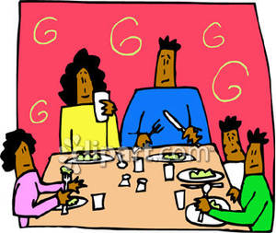
Conclusions
Mothers in the four different cultural groups in this study conveyed different messages to their infants about how to learn, how to fit into the group, and how to be autonomous. Filipino- and Japanese-American mothers were highly attentive and affectionate toward their infants, but also either overtly (Filipino-American) or subtly (Japanese-American) controlling. Mothers conveyed the message that being a member of a tight family group involves both the warmth and attentiveness of belonging and also the obligations of conforming to adult wishes. The Caucasian-American mothers in this sample allowed more autonomy and were more relationally distant. They encouraged innovation as they focused on infants' completing their goal-directed actions - regardless of whether these disrupted the rest of the group. The Native Hawaiian mothers in this study enabled autonomy but also insisted on conformity when infant actions began to disrupt the group.
Mothers in this study also sent messages about appropriate ways to make contact with other people. Caucasian­American parents emphasized making contact through talking and calling out during meals. One purpose of mealtimes was for talking and expressing plans and goals; infants tried to participate in these conversations by babbling loudly. Japanese-American mothers conveyed the message that an appropriate way to make contact with adults is to try a task and to elicit help in completing in. Hawaiian-American mothers conveyed the message that the appropriate way to make contact with adults is to behave autonomously on the sidelines and to initiate contact when the adult is available to receive you.
Parents' cultural values and beliefs, the ways they organize and teach their infants during mealtimes, and the ways infants approach learning in the context of family mealtimes seem closely - and complexly - interrelated. Parents mediate their infants' learning by setting up learning environments­ in this case, mealtimes- in particular ways, and shape their infants' moment-to-moment actions and interactions within these settings. Infants' approaches to learning are, in turn, affected by how their parents set up and shape mealtime interactions. Our study suggests that "a typical weekday evening meal" may be a microcosm of a family's culturally distinctive approach to shaping children's learning.

Article Review Questions

Throughout this course you will be given many different resources to review as a way to enhance the materials covered in class. You are responsible to read and familiarize yourself with these materials. To help you with this process I have developed some review questions to go along with some of the articles. These questions will need to be handed in and will count as part of your grade (participation). They will not be accepted late as they will be used to promote participation the day they are due.

Martini, M. (2002). How mothers in four American culture groups shape infant learning during mealtime. Zero to Three.

- What were the differences in the parenting styles that were explained in the article? Why do you think there were differences?
- What cultural differences were different than yours and what was your opinion (and why) of these practices?
- How did this article impact/change the way you may consider mealtimes with young children?

Additional Resources and
Materials

Fact Sheet: Universal Precautions

What are universal precautions?
Blood and other body fluids (i.e., semen, vaginal fluids, saliva, urine, feces, vomit) can contain viruses and bacteria that can be passed on to another person through direct contact. Hepatitis B & C and HIV are diseases that can be transferred from one person to another through contact with infected blood and/or body fluids. Since there is no way to know without testing if a person has hepatitis B or C or HIV, it is recommended that you treat all body fluids as though they were infected.

Universal Precautions are actions that you take to place a barrier between yourself and potentially infected body fluids.

How are blood and body fluids passed from one person to another?
• Through open areas on the skin
• By splashing in the eye
• Through the mouth
• Unprotected sexual activity (oral, anal and vaginal)
• Injury with contaminated needles or other sharps
• Prenatally (mother to baby) and during delivery

How can I protect myself from blood and body fluids?
The easiest way to protect yourself from blood and body fluids is to have the injured person treat their own wound. If they are unable to take care of themselves, or they need some help, use latex gloves. If you do not have disposable gloves available, use a plastic bag (trash, shopping, or sandwich) over your hands to create a barrier. Your employer must provide appropriate personal protective equipment (gloves, goggles, disinfectant, etc.) for your use while at work. Know where these items are located so that you will be better prepared to protect yourself.
How do I safely handle a bleeding injury?
1. The child or adult should hold an absorbent material to the wound - a clean disposable diaper offers a good absorbent material with the added protection of a plastic backing. You can also use paper towels, tissue, or newspaper.
2. Have them hold pressure until the bleeding stops.
3. Assist with placing a bandaid or bandage over the wound if needed.
4. Dispose of bloody material in a plastic lined trashcan or sealed plastic bag.
5. Everyone should wash his or her hands with soap
& running water as soon as possible (disinfectant waterless hand cleaners or towelettes may be used if soap and running water are not available).

How do I clean surfaces that have blood and body fluids on them?
1. WEAR DISPOSABLE GLOVES.
2. Wash the area with soap and water, and dry the area.
3. Disinfect the surface with a solution of one part bleach to ten parts water, or you can use a hospital-strength disinfectant (i.e., Lysol, Cavicide, or NABC). Allow the area to remain wet for at least 3 minutes, before drying. Consult the container label for differences in recommendations due to product strength.
4. Use disposable cleaning materials if possible, such as paper towels instead of cloth.
5. Dispose of cleaning materials and gloves in a
sealed plastic bag.
6. Wash hands with soap and running water (disinfectant waterless hand cleaners or towelettes may be used if soap and running water are not available).

This fact sheet is for information only and is not meant to be used for self -diagnosis or as a substitute for consultation with a health care provider. For more information call your health care provider or call Washtenaw County Public Health at 734-544-6700.

Visit our website at: http://publichealth.eWashtenaw.org
Or the Centers for Disease Control & Prevention at: www.cdc.gov
Washtenaw County Public Health 555 Towner Ypsilanti, MI 48198 revised 1/08

What Mandated Reporters Need to Know
Summary of Connecticut's Child Abuse Reporting Laws
The following is an outline of the legal requirements of "mandated reporters," those professionals who, because their work involves regular contact with children, are mandated by law to report suspected child abuse and neglect. For a complete copy of the law, refer to Sections 17a-101 through 17a-103a, inclusive of the Connecticut General Statutes.
Who Must Report
Connecticut law requires certain citizens to report suspected child abuse and neglect. These mandated reporters are people in professions or occupations that have contact with children or whose primary focus is children. The law requires that they report suspected child abuse or neglect. Under Section 17a-101 of the Connecticut General Statutes, the following are considered mandated reporters:
- Any person paid to care for a child in any public or private facility, child day care center, group day care home or family day care home which is licensed by the State.
- Battered Women’s Counselors
- Chiropractors
- Dental Hygienists
- Dentists
- Department of Children and Families Employees
- Department of Public Health employees responsible for the licensing of child day care centers, group day care homes, family day care homes or youth camps.
- Foster Parents
- Judicial Department Employees (Family Relations Counselors, Family Counselor Trainees, Family Services Supervisors *as of 10-01-2010)
- Licensed/Certified Alcohol and Drug Counselors
- Licensed/Certified Emergency Medical Services Providers
- Licensed Marital and Family Therapists
- Licensed or Unlicensed Resident Interns
- Licensed or Unlicensed Resident Physicians
- Licensed Physicians
- Licensed Practical Nurses
- Licensed Professional Counselors
- Licensed Surgeons
- Medical Examiners
- Members of the Clergy
- Mental Health Professionals
- Optometrists
- Parole Officers (Juvenile or Adult)
- Pharmacists
- Physical Therapists
- Physician Assistants
http://www.ct.gov/dcf/cwp/view.asp?a=2556&q=314384&pp=12&n=1 8/15/2012
- Podiatrists
DCF: What Mandated Reporters Need to Know Page 2 of 5
- Police Officers
- Probation Officers (Juvenile or Adult)
- Psychologists
- Registered Nurses
- School Employees - as stated in section 53a-65 (subsection 13) "School employee" means: (A) A teacher, substitute teacher, school administrator, school superintendent, guidance counselor, psychologist, social worker, nurse, physician, school paraprofessional or coach employed by a local or regional board of education or a private elementary, middle or high school or working in a public or private elementary, middle or high school; or (B) any other person who, in the performance of his or her duties, has regular contact with students and who provides services to or on behalf of students enrolled in (i) a public elementary, middle or high school, pursuant to a contract with the local or regional board of education, or (ii) a private elementary, middle or high school, pursuant to a contract with the supervisory agent of such private school.
- Sexual Assault Counselors
- Social Workers
- School Coaches or Coaches of Intramural or Interscholastic Athletics
- The Child Advocate and any employee of the Office of the Child Advocate.
What Must Be Reported
Mandated reporters are required to report or cause a report to be made when, in the ordinary course of their employment or profession, they have reasonable cause to suspect or believe that a child under the age of 18 has been abused, neglected or is placed in imminent risk of serious harm. (Connecticut General Statutes §17a-101a)

Child abuse occurs where a child has had physical injury inflicted upon him or her other than by accidental means, has injuries at variance with history given of them, or is in a condition resulting in maltreatment, such as, but not limited to, malnutrition, sexual molestation or exploitation, deprivation of necessities, emotional maltreatment or cruel punishment. (Connecticut General Statutes §46b-120)

Child neglect occurs where a child has been abandoned, is being denied proper care and attention physically, emotionally, or morally, or is being permitted to live under conditions, circumstances or associations injurious to his well-being. (Connecticut General Statutes §46b-120)

When making a report, a mandated reporter is required to provide the following information, if known:

- The names and addresses of the child and his parents or other person responsible for his care;
- The age of the child;
- The gender of the child;
- The nature and extent of the child's injury or injuries, maltreatment or neglect;
- The approximate date and time the injury or injuries, maltreatment or neglect occurred;
- Information concerning any previous injury or injuries to, or maltreatment or neglect of, the child or his siblings;
- The circumstances in which the injury or injuries, maltreatment or neglect came to be known to the reporter;
- The name of the person or persons suspected to be responsible for causing such injury or injuries, maltreatment or neglect;
- The reasons such person or persons are suspected of causing such injury or injuries, maltreatment or neglect;
- Any information concerning any prior cases in which such person or persons have been suspected of causing an injury, maltreatment or neglect of a child;
- Whatever action, if any, was taken to treat, provide shelter or otherwise assist the child (PA 11-93 §15).
http://www.ct.gov/dcf/cwp/view.asp?a=2556&q=314384&pp=12&n=1 8/15/2012
How to Report
Mandated reporters must report orally to the Department of Children and Families' (DCF) Hotline or a law enforcement agency within 12 hours of suspecting that a child has been abused or neglected and must submit a written report (DCF-136 form) to DCF within 48 hours of making the oral report. When the Mandated reporter is a member of the staff of a public or private institution or facility that provides care for children or a member of a public or private school, they must also provide written notification to the head of the facility or institution where the alleged victim is enrolled or registered. DCF is required to tape record all reports to the Hotline.
Special reporting requirements may apply for staff members of a public or private institution or facility that cares for such child, or a public or private school. (See pages 4-5).
Police must report to DCF immediately upon receipt of any oral report of abuse or neglect.
Upon receipt of any oral report alleging sexual abuse or serious physical abuse or serious neglect, DCF must report to the appropriate state or local law enforcement agency within 12 hours.

Anonymity

Mandated reporters are required to give their name when they make a report to DCF, however, reporters may request anonymity to protect their privacy. This means that DCF would not disclose their name or identity unless mandated to do so by law (Connecticut General Statutes, Sections 17a-28 and 17a-101). Unless a reporter gives written consent, his or her name will not be disclosed except to:
- a DCF employee
- a law enforcement officer
- an appropriate state's attorney
- an appropriate assistant attorney general
- a judge and all necessary parties in a court proceeding
- a state child care licensing agency, executive director of any institution, school or facility or superintendent of schools
If DCF suspects or knows that the reporter knowingly makes a false report, his or her identity shall be disclosed to the appropriate law enforcement agency and the person may be subject to the penalty described in the next section.

Immunity and Penalty
Mandated reporters are required to make a referral to the DCF Hotline as soon as practical but no later than 12 hours after the mandated reporter becomes aware of or suspects abuse/neglect or imminent risk of serious harm to a child or children. Any person required to report who fails to make such report or fails to make such report within the time period prescribed (in sections 17a-101b to 17a-101d), could be fined not less than five hundred dollars ant not more than two thousand five hundred dollars and could be required to participate in an educational and training program (pursuant to subsection (d) of section 17a-101). The Department shall promptly notify the Chief State's Attorney when there is reason to believe that any such person has failed to make a report in accordance with this section.
Mandated reporters identified as a school employees (as defined in section 53a-65 (subsection 13) of the Connecticut General Statutes (CGS), can be subject to an investigation and the penalties stated above if they fail to make a report (OR) if they fail to make a report within the 12 hour timeframe. The Commissioner of the Department of Children and Families, or the commissioner's designee, shall promptly notify the Chief State's Attorney when there is reason to believe that any such person has failed to make a report in accordance with this law.
Immunity from civil or criminal liability is granted to people who make required reports in good faith. Immunity is also granted to people who in good faith have not reported.
Anyone who knowingly makes a false report of child abuse or neglect shall be fined up to $2,000 or imprisoned for not more than one year, or both. The identity of any such person shall be disclosed to the appropriate law enforcement agency and to the perpetrator of the alleged abuse.
Employers may not discharge, discriminate or retaliate against an employee for making a good faith report or testifying in an abuse or neglect proceeding. The Attorney General can bring a court action against any employer who violates this provision, and the court can assess a civil penalty of up to $2,500 plus other equitable relief.
http://www.ct.gov/dcf/cwp/view.asp?a=2556&q=314384&pp=12&n=1 8/15/2012

Informing the Family

Mandated reporters are under no legal obligation to inform parents that they have made a report to DCF about their child. However, depending on the circumstances, it may be necessary and/or beneficial to do so.
- When a child is suspected of being abused, neglected or placed at imminent risk of serious harm by a member of the staff of a private or public school or an institution that cares for the child, the person in charge of the school or facility must notify the child’s parent or other person responsible for the child’s care that a report has been made. It is DCF’s responsibility to notify the head of such school, facility or institution that a report has been made.
- Health care professionals may need to talk with parents to assess the cause of the child’s injury(ies). Mental health professionals or members of the clergy may want to talk with the parents to offer support and guidance.
However, in cases of serious physical abuse or sexual abuse, it may not be wise to talk with parents before reporting the case to DCF. This may put the child at greater risk and could interfere with a potential criminal investigation.

Investigation of Abuse or Neglect Report

DCF is responsible for immediately evaluating and classifying all reports of suspected abuse/ neglect/imminent risk. If the report contains information to warrant an investigation, DCF must make its best effort to begin an investigation within two hours if there is an imminent risk of physical harm to a child or another emergency; and within three days for all other reports. In all cases, DCF must complete the investigation in 30 calendar days.
When conducting a child abuse or neglect investigation, DCF or a law enforcement agency must coordinate activities to minimize the number of interviews with any child.
DCF must obtain consent from the parent, guardian or person responsible for the child's care for any interview, unless DCF has reason to believe such person or a member of the child's household is the alleged perpetrator. When such consent is not required, the interview must be conducted in the presence of a 'disinterested adult' (typically, a person who is impartial and has no self-interest in the case). If a disinterested adult is not available after reasonable search and immediate access is necessary to protect the child from imminent risk of serious harm, DCF or a law enforcement agency will still interview the child.
If, after the investigation has been completed, serious physical abuse or sexual abuse is substantiated, DCF must notify the local police, and either the Chief State's Attorney/designee or a state's attorney in the judicial district in which the child resides or in which the abuse occurred. A copy of the investigation report must also be sent.
Suspected Abuse By a School Employee
Mandated reporters are required to report any suspected child abuse, neglect or imminent risk of serious harm directly to DCF or the police. This includes situations when the alleged perpetrator is a school employee. DCF must notify the head of the school that a report has been made, unless such person is the alleged perpetrator.
Investigations of suspected child abuse, neglect or imminent risk of serious harm by a school employee as stated in CGS section 53a-65 (subsection 13) are conducted by DCF. If, after such investigation, DCF has reasonable cause to believe that a child has been abused by a school employee who holds a certificate, permit, or authorization issued by the state, DCF shall notify the employing superintendent and the Commissioner of Education of such finding and shall provide him or her with records concerning such investigation. Please use this link for additional information and changes contained in Public Act 11-93 as it pertains to suspected abuse by a school employee.
http://www.ct.gov/dcf/cwp/view.asp?a=2556&q=314384&pp=12&n=1 8/15/2012
The Superintendent must suspend such employee. The suspension shall be with pay and will not diminish or terminate the employee's benefits. Within 72 hours after such suspension, the Superintendent shall notify the local or regional board of education and the Commissioner of Education of the reasons for and conditions of the suspension. The Superintendent shall disclose the DCF records to the Commissioner of Education and local or regional boards of education or their attorney for purposes of review of employment status or certification. The suspension must remain in effect until the local Board of Education takes action.
If the employee's contract is terminated, the Superintendent shall notify the Commissioner of Education or his representative within 72 hours. The Commissioner of Education may then commence certification revocation proceedings.
The Superintendent may suspend any other school staff member in similar circumstances.
The State’s Attorney must notify the Superintendent, or supervising agent of a non-public school, and the Commissioner of Education when a certified school employee, or any person holding a certificate issued by the State Board of Education, is convicted or a crime involving an act of child abuse or neglect.
Suspected Abuse By a Member of An Institution or Facility Providing Child Care

Mandated reporters are also required to report when they have reasonable cause to suspect or believe that any child has been abused or neglected by a member of the staff of a public or private institution or facility that provides care for children. DCF must notify the head of the institution or facility providing child care that a report has been made, except in circumstances when such person is the alleged perpetrator.
Whenever DCF, based on the results of an investigation, has reasonable cause to believe that that a child has been abused or neglected by a staff member of a public or private institution or facility providing child care, DCF shall notify the executive director of the institution, school, or facility in not less than five working days. DCF shall also provide records concerning the investigation to the executive director. If the facility is licensed by the state for the caring of children, DCF shall notify the state agency that licenses it and provide records concerning the investigation. Please use this link for additional information and changes contained in Public Act 11-93 as it pertains to suspected abuse by a member of an institution or facility providing child care.

TRAINING

DCF provides Mandated reporter training to all providers in the state of Connecticut upon request. For additional information regarding Mandated Reporter training for your organization, agency, or facility, please use this link.

WHERE TO CALL

The Department has a single point of contact statewide for the reporting of suspected child abuse and neglect. This Child Abuse and Neglect Hotline operates 24 hours a day and seven days a week. Anyone who suspects that a child has been abused or neglected or is in danger of abuse or neglect is strongly encouraged to call the Hotline.

Content Last Modified on 11/7/2011 2:09:21 PM

