Structural Design

CIV-222 (Ground)
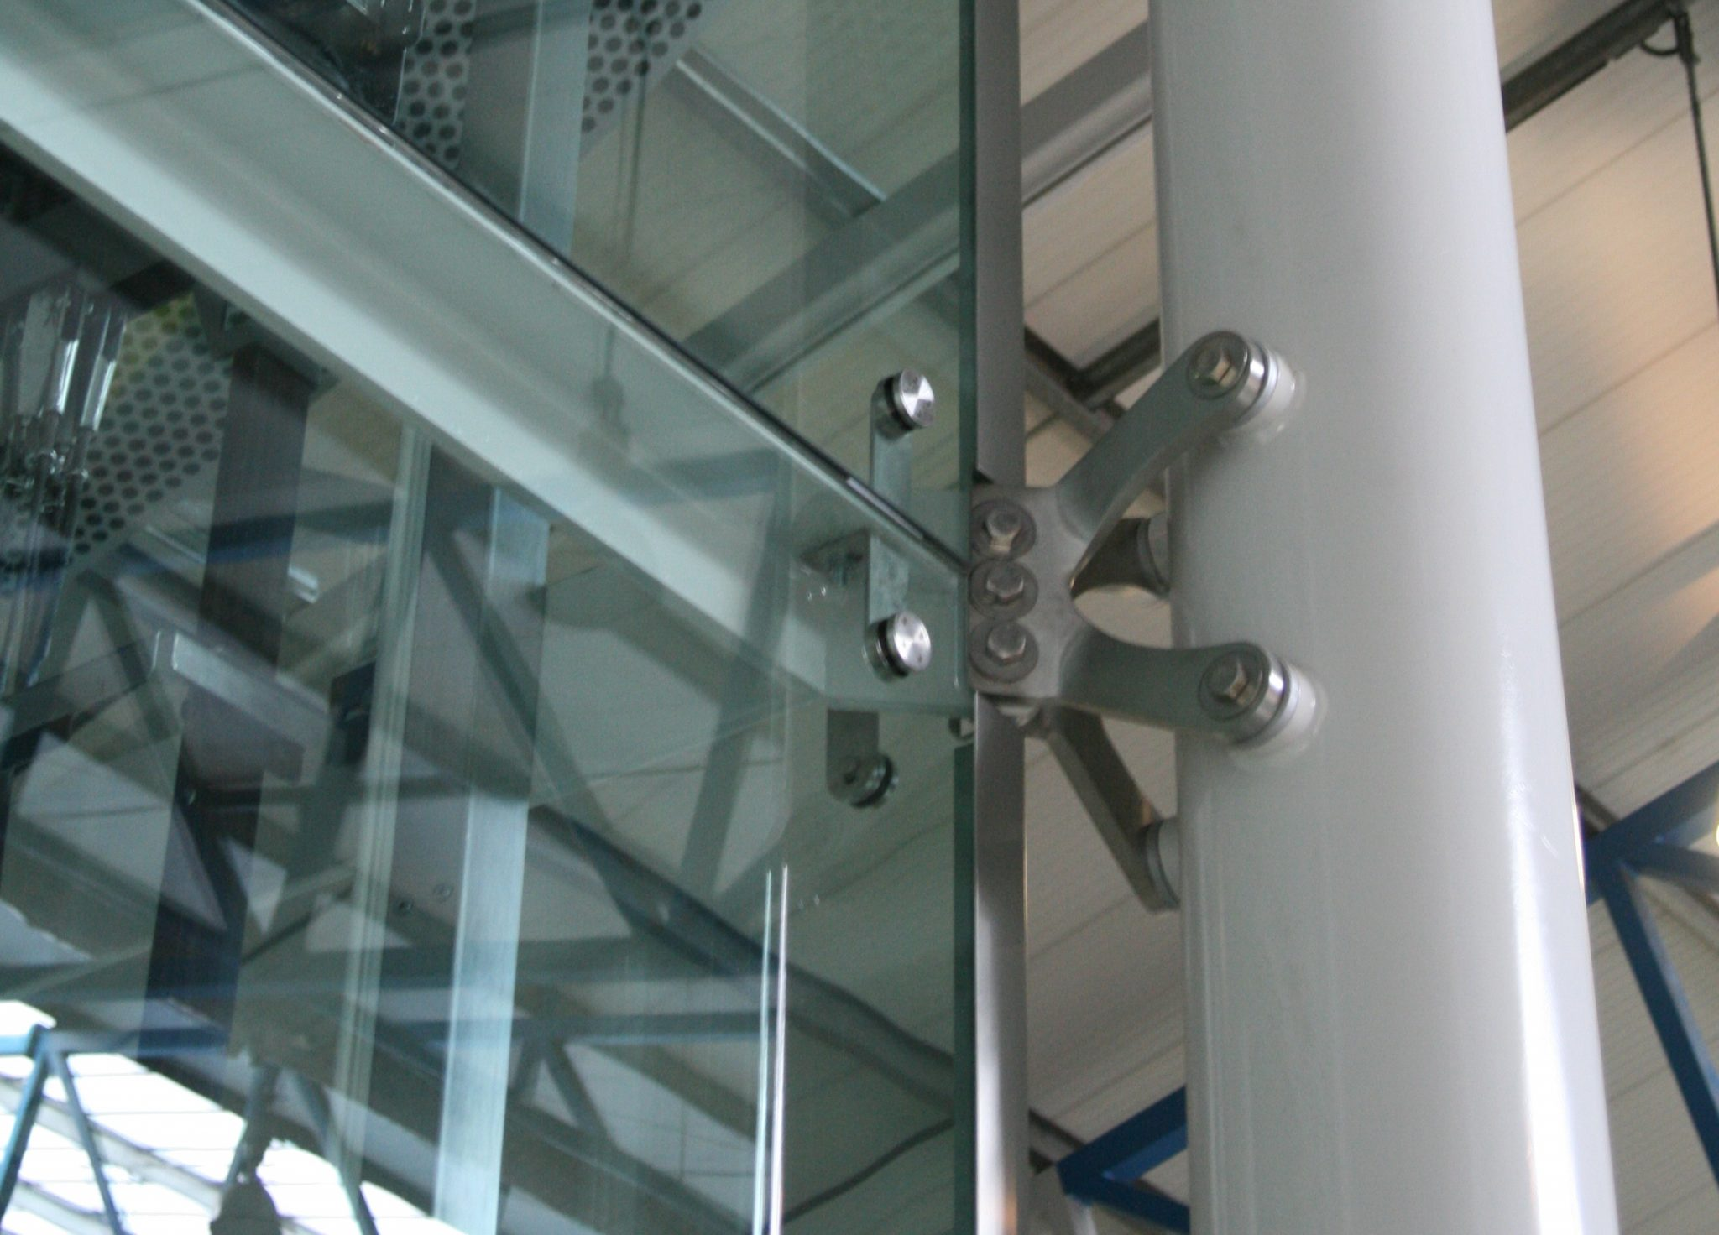
Professor:
Mark A. Comeau

Office C-218
Office Hours:
Mon. 4:30-6:00 PM
Wed. 4:30-6:00 PM

Email:
mcomeau@trcc.commnet.edu

Sections:
33532 Wed 6:00-8:45 PM D-122

Course Description

The names and functions of various statically-determined structural steel and concrete members and systems are discussed and analyzed including footings, columns, beams, slabs, trusses, and connections. Students will practice solving designs for shear, bending moment and deflection through analytic methods according to current specifications using appropriate design techniques, manuals, and theory, and practice graphical detailing of designs according to current practice.

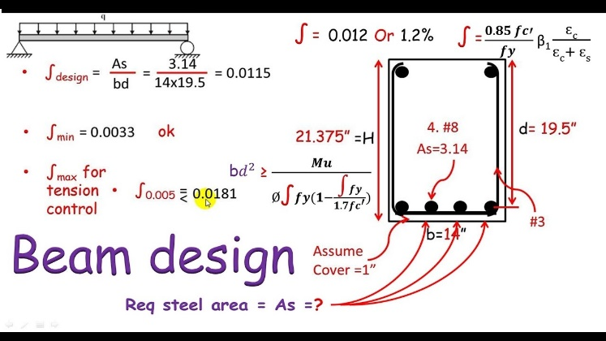
Materials, Supplies & Resources
You will use the following:
- Lined or grid-ruled notebook;
- Instructor supplements will be provided;
- Handouts
- Formulaic calculation examples
- Lecture notes (provided thru Blackboard)
- Structural Drawings
Course Textbook
Textbook (Optional):
Smith, Paul. Structural Design of Buildings, 1st Ed., Hoboken: John Wiley & Sons, Inc., 2016.
ISBN 978-111883941-6
Suggested Readings:
Garrison, Philip. Basic Structures, 3rd Ed., Hoboken: John Wiley & Sons, Inc., 2014.
ISBN 978-111895087-6
Course Requirements
▪ Attendance is required for academic success. ▪ Upload you projects on time!
▪ Leaving the lecture and returning is disruptive ▪ Be ON TIME for the demonstration as once
and allowed only in emergencies. started, it will not be repeated!
▪ Try not to fall behind during demonstrations. ▪ Help each other.
▪ Late projects have a grade-cap of “B”. ▪ You must “put the time in”.
▪ Use your out-of-class time wisely. ▪ You will be operational after this class
The Class Method
The class consists of three distinct portions:

1. The Lecture 2. Calculation Demonstration 3. Solution Modeling

Attending class is essential for understanding unit concepts and learning formulaic operations. You will apply what has been demonstrated as you complete the assigned projects and upload them for assessment on Blackboard.
Topical Outline
Structural Concepts |  |  | Structural Systems, Form & Concrete
Unit 1 | “The Nature of Things” |  | Unit 8 | Beams
 | Organic Structures in Nature |  |  | Reinforced Concrete Beam Design
Unit 2 | Historic Applications |  | Unit 9 | Slabs
 | Exploration & Innovation |  |  | Reinforced Concrete Slab Design
Unit 3 | Loads and Their Behavior |  | Units 10 | Columns & Footing
 | Force, Stress, Equilibrium, Elements |  |  | Reinforced Column/Footing Design
Structural Systems, Form & Wood |  |  | Related Structural Systems
Unit 4 | Wood: Post & Lintel |  | Units 11 | Site & Geo-technic
 | Columns, Bearing & Shear |  |  | Soil Mechanics
Unit 5 | Wood: Post & Lintel Cont’d |  | Unit 12 | Floor Systems
 | Beams, Joists & Bending |  |  | Joists & Decking Systems
Unit 6 | Composite Systems |  | Unit 13 | Roof Systems
 | Arches, Plates & Frames |  |  | Rafters, Trusses, Panels
Unit 7 | Assessing Reactions |  | Unit 14 | Final Assessment
 | Efficiency, Rigidity & Verifications |  |  | Capstone Project
Grading: Secondary Assessments
Methods: Additional assessments that have weight on the final grade are:

Assumptions: Approach to solutions;
Orders: Order of operations;
Solutions: Recommended solution and acceptable options.

Grading: Primary Assessments
Projects: There will be an assignment for each unit topic for you to complete. You will be graded on:

Concept: Understanding of concepts;
Application: Ability to apply concepts;
Details: Accuracy.

Structural Design Overview
Architecture – the application of form, space and order, is the discipline that resides in both the arts and the sciences.
From the arts side, the marriage of function and metaphor underlie the theories of good design and the product of creative spaces that are functional to use and meaningful on other planes.
From the science side, the underlying systems of structure should lead to and contribute to the architectural form – as in the systems of the natural world.

Structure as Systems:
Nature uses membrane, skeletal, and other “systems” of support in all things within the natural World. The human built environment is more efficient and sustainable when it applies the millions of years of “R&D” already vetted by nature. Designers need to consider buildings as entire systems that synergistically work together – not as separate components that contribute a singular aspect to the whole.

Structural Types:
Architectural designs can employ form derivatives from shells, membranes, frames, and other types. In the portion of the course, you’ll become familiar with these; how they derive their shape, their strength, and what materials are optimal. Additionally, you’ll become familiar with how the respond to forces – both inherent and applied and statically and dynamically.

Structures in Wood/Steel:
Once we’ve established a basic understanding of structural types, we’ll move into variations of wood structures, learning how to assume forces, calculate loads, and solve for structural sizes both nominal and laminar.

Structures in Concrete:
Next, we’ll explore the types and methods of one of the oldest man-made structural types – concrete. As concrete finds it’s advantage in compression, it had no tensile strength; we therefore need to understand the theory of reinforcement (rebar), where it goes and how it is sized. We’ll be performing step-by-step operations to size concrete columns, beams and slabs.

Related Structure:
Lastly, we’ll be exploring aspects of soil and geo=technics, wall, roof and fenestration systems. Our final task will be a capstone project in which you’ll be given a design problem for which you’ll create a structural solution and provide the calculations used to arrive at that solution.

Course Objectives, Student Learning Outcomes (SLO’s), Assessment & Mapping
Course Objective | SLO | Method of Assessment | Mapped to PO*
Become familiar with structural systems of shells, frames, membranes, etc. found in nature. | 1. Develop an understanding of natural forms of structure of nature’s built-in efficiencies using materials. | Exam; Unit exams will measure content comprehension.  The Project-based assignments assess the student’s ability to differentiate between systems of structure. | (PO) Program Outcome #2, #3.  GenEd n/a  LAS/GS n/a
Understand how cultures have experimented with and innovated structure over time. | 2. Develop an understanding of the historical evolution of human-built structures over time. | Exam; Unit exams will measure content comprehension.  The Project-based assignments assesses the student ability reference cultures and the systems they used. | (PO) Program Outcome #2, #3.  GenEd n/a  LAS/GS n/a
Practice analyzing the limits of various systems by modeling forms and understanding fail-points. | 3. Practice the exploration of structural systems – their materials, assemblies and capabilities, through modeling and forced-failure in design. | Exams; Unit exams will measure content application.  The Project-based assignments require students to apply concepts as they create models, apply loads and create failure by design. | (PO) Program Outcome #2, #3.  GenEd n/a  LAS/GS n/a
Perform basic calculations to size wood, concrete, and steel structures. | 4. Demonstrate working knowledge of the properties and behavior of wood, timber, steel, and concrete in various structural modes. | Exams; Unit exams will measure content application.  The Project-based assignments require students to analyze structural givens, make assumptions and perform calculations to size solutions. | (PO) Program Outcome #2, #3, #5.  GenEd n/a  LAS/GS n/a
Produce a basic structural design based on parameters assigned, including drawings, calculations and required annotations. | 5. Demonstrate working knowledge basic structural mathematical computations in a course capstone project:  - Size structural components using formulaic calculations;  - Verify limits of deflection;  - Create graphic drawings that illustrate the structural solution. | Exams; Unit exams will measure content application and analysis.  Project-based assignments provides students with practice projects for exploring and developing their techniques.  The course capstone project measures the students ability to 1) solve a structural problem while basing assumptions, 2) model calculations for structural sizing, 3) verify design limits and create structural drawings. | (PO) Program Outcome #2, #3, #5, #6.  GenEd n/a  LAS/GS n/a
* PO’s (Program Outcomes) are found in the CT A.A.S. Program’s Continuous Improvement Plan.
Student Resources

Advising & Counseling
https://www.trcc.commnet.edu/student-services/advising-and-counseling-center/

Sexual Misconduct
https://www.trcc.commnet.edu/student-services/sexual-misconduct-resources-and-education/

Student Handbook
https://www.trcc.commnet.edu/wp-content/uploads/2017/06/trccstudenthandbook.pdf
Academic Resources

Log In & Net ID
https://www.trcc.commnet.edu/learning-resources/educational-technology/student-resources/5-steps-for-getting-started/

General Resources Web Page: eLearning, Blackboard, Online, Hybrid, Help Desk
https://www.trcc.commnet.edu/learning-resources/educational-technology/student-resources/

Academic Calendar
https://catalog.threerivers.edu/content.php?catoid=5&navoid=294
Policies

General Policies
https://catalog.threerivers.edu/content.php?catoid=5&navoid=240

Academic Integrity
https://catalog.threerivers.edu/content.php?catoid=5&navoid=240#Academic_Integrity_Policy

Faculty and Staff
https://www.threerivers.edu/directory/

Weather & Cancellations
1-860-215-9000 Press 1 for College Closing Announcement -or- https://www.threerivers.edu/ (for posted announcement)

