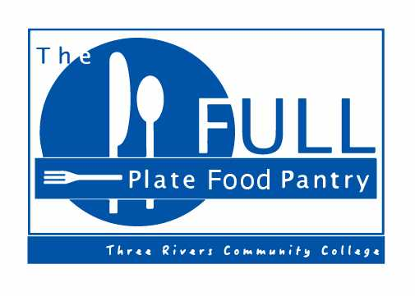
The food pantry is now open!
D-111
Stop in and check it out!

All sorts of items: spaghetti sauce, pasta, soups, peanut butter, rice, taco mixes, tuna, macaroni and cheese, baby items, etc.

Hours:
Monday 10:30-5:00
Tuesday 10:30-3:00
Wednesday 10:30-6:00
Thursday 10:30-4:00

*Hours are subject to change, so look for the sign outside of the door (D111). (If it is not out, check back later.)

