Syllabus
Mat 285 Differential Equations Fall 2018 CRN# 32961 Professor June Decker
Class meetings Tuesday Thursday 5-6:15 Room D212
Prof Decker’s Office #C124 phone: 860 215 9420 jdecker@trcc.commnet.edu
WebEx for virtual office hours: https://ctedu.webex.com/join/JDeckertrcc.commnet.edu meeting number 64 844 022
Office hours: Monday 8-9:30 AM in room D219, Thursday 4-5, Virtual Office Hours on WebEx: Monday 7:30-9 PM . Additional Office hours available by appointment.

Pre-requisite: MAT K256 Calculus 2.
Text: Notes on Diffy Qs: Differential Equations for Engineers by Jiri Lebl – open source course ware. https://www.jirka.org/diffyqs/ also available under COURSE CONTENTS on Blackboard.

Course Description: A continuation of Calculus with introduction of standard techniques of
solving differential equations. The following topics will be introduced:
first - order differential equations, linear equations of higher order, power
series methods, Laplace transform methods, linear systems of
differential equations, numerical methods, and modeling by differential
equations in a variety of applications in physics, chemistry, engineering,
biology, social sciences, and finances.
Course Outcomes: Upon successful completion of this course, the student will be able to:
- Solve first order equations by analytical, graphical and numerical methods.
- Use first order and systems of equations for modeling.
- Identify and solve applications on first order equations (decay, growth, population model,
acceleration and velocity problems).
- Solve second order homogenous equations with constant coefficient and various
applications on vibrations, electrical circuits.
- Solve Differential equations by the eigenvalue method
6. Differential Equations by Laplace Transforms.
7. Model Special Forcing Terms using Delta functions.
8. Convert higher order equations to systems of equations.

Grading System Class work 13%
3 tests, each test – 20%,
1 quiz 7%
Cumulative final exam – 20%.

Your class work grade will be earned as follows: For your class attendance and participation you will earn
half a point per class for 30 classes including exams and test. You must be present for most of the class
and engaged in the work of the class for most of the class to receive half a point for that day. Being
engaged also means that you come to class prepared by reading the text – that is Prof Lebl’s notes or
the equivalent, and have done a significant portion of the assigned problems. If I feel as if you are not prepared, I will let you know so we can discuss it. I may ask you to show me your notebook to verify that you are prepared for class. There will be no make ups for class absences. Note that you can miss 4 out of30 classes and still get all the available class participation points.

Grade equivalents: A 93 – 100, A- 90 – 93, B+ 87 -89, B 83 – 86, B- 80 – 82, C+ 77 – 79, C 73 – 76, C- 70 – 72, D+ 67 – 69. D 63 – 66. D- 60 – 62, F below 60.

Attendance:
Your attendance in the classroom, participation in classroom work/projects and preparation for each class is
required and is essential to success in the course. You may not make up class work for a grade if you are not
in attendance. If you miss a chapter test or do poorly on a test, you will be given a copy of the test that was
taken by the class, and you will be able to make up ONE test during the last week of the semester at a time
we agree upon. (Sometime between Dec 10 and 14). Since anyone can make up ONE test, it is to your
advantage to try to take a test even if you feel you are not ready for it.

Support Services: Tutorial services (TASC 860 215 9082). Meeting with me for extra help during office hours or by appointment.

Class Cancellation: Class will not be held if the college is closed. Sign up for MY COMMNET ALERT to receive phone calls or texts of college closings. If it is icy and dangerous for you to travel, please choose to be safe even if you have to miss class. I understand that road conditions vary greatly within our service area. I will not count absence against you if it is on a day that is unsafe to travel.
If I cancel class, a note will be posted on the classroom door. If there is time, I will email the class using your college email, and I will post an announcement on Blackboard. Feel free to text my cell phone if you are in doubt about the class meeting 860 377 7788.

COLLEGE WITHDRAWAL POLICY
Course withdrawals are accepted up until the week before classes end – Dec 7 in person at student services and Dec 9 online. Specific dates are posted in the academic calendar and withdrawal forms are available online or at the Registrar’s office. The withdrawal does not have to be signed by the instructor, but it is strongly recommended that you speak with your instructor before withdrawing so we can discuss other options such as Incompletes. If you are receiving financial aid you must contact their office for approval before withdrawing. If necessary, you can withdraw over the phone by calling the Registrar’s Office at 860-215-9064

ACADEMIC INTEGRITY POLICY
All students are expected to demonstrate their knowledge of the material on each problem set, quiz and test. Any student caught cheating will receive a zero on that test or quiz or problem set. You may receive help of any kind on all your work except that the final exam is to be done by you and you alone without any notes. That is why the final exam is Proctored. Even though you are allowed to get help on any work your do (except the final exam) you must understand the content of the course and the problems you do – even if you get help with them – and you must be able to do the problem without help by the end of the semester. Help can take the form of communicating with another person, looking up how to do something from another textbook or from a source on the internet, looking at your notes, looking at an answer key, etc.

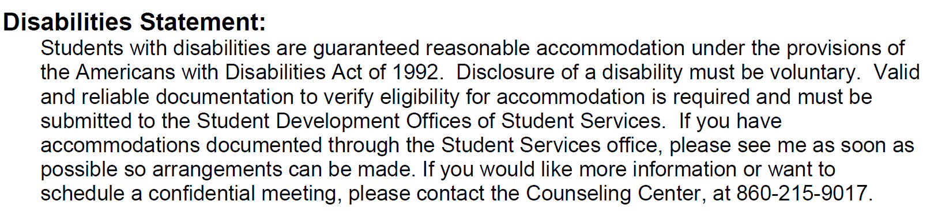
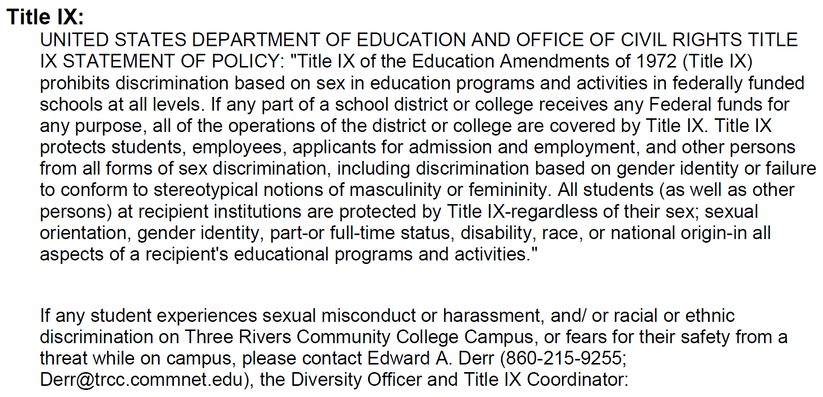

DIGICATION is an online learning portfolio provided by the college. Students are expected to maintain a portfolio. Please submit your worked out solutions to the Midsemester problem set on digication. Further directions will be given in early October.

Differential Equations, Tentative Schedule
Note: Oct 16 is not a class day on the official TRCC Calendar. We can vote to replace our scheduled class on Nov 20 (two days before thanksgiving) with the Oct 16 Tuesday 5-6:15 time. IF anyone objects, please let me know in private by Sept 5. I will not make the change if it causes any issues of any kind.The sections listed below are from the Jiri Lebl NOTES ON DIFFY Qs. In general, the do the problems at the end of each section of the text.
Week 1. August 28 -30 Ch 0 and Sections 1.1, 1.2 Do problems on pages 12, 15-16, 21, 25-26. Do graph some slope fields by hand. To graph slope fields using technology, use ti 89, graphing mathlets or applets for Diff Equations by Robert Decker on his University of Hartford website https://www.desmos.com/calculator/p7vd3cdmei
or by downloading apps to your cell phone or computer for either DESMOS or GEOGEBRA free graphing calculators and Computer Algebra Systems (CAS).
Week 2: Sept 4-6. Sections 1.3, 1.4, 1.5 For the future, do problems in the text at the end of each section unless otherwise noted.
Week 3 Sept 11-13 Sections 1.6, 1.7
Week 4 Sept 18-20 Sections 1.8 and Review ch 0-1

Week 5 Sept 25 TEST ON CH 0-1. For the test you are allowed to bring in 4 pages of notes that is slightly less than half a page of notes per section – your choice as to how to break it up) Page must be normal note book sized 8.5” by 11”. Type (or handwriting) must be at least an “8 point font” , the typing in this paragraph is an 8 point font. Two lines of writing span a centimeter, or five lines of writing spans an inch. NO CELL PHONES< NO COMPUTERS
Sept 27 section 2.1

Week 6 Oct 2-4 Sections 2.2, 2.4 (skip 2.3)
Week 7 Oct 9-11 Sections 2.5, 2.6
Week 8 Oct 16-18 Sections 3.1, 3.2
Week 7 Oct 23-25 Sections 3.3, 3.4
Week 8 Oct 30 – Nov 1 Sections 3.5, 3.6

Week 9 Nov 6 TEST ON CH 2-3 For the test you are allowed to bring in 4 pages of notes that is slightly less than half a page of notes per section – your choice as to how to break it up) Page must be normal note book sized. Type (or handwriting) must be at least an “8 point font”. Two lines of writing span a centimeter, or five lines of writing spans an inch. NO CELL PHONES, NO COMPUTERS
November 8: section 6.1

Week 10 Nov 13-15 Sections 6.2 and 6.3
Nov 20 : thanksgiving week : Vote to have class or no class . Replace Nov 20 class with Oct 16. Secret vote by email to jdecker@trcc.commnet.edu by Sept 4 to be announced in class sept 5. IF one person is inconvenienced by switching to Oct 16, we will use the established class date of Nov 20
Week 11 Nov 27-29 Sections 6.4, 8.1
Week 12 Dec 4 TEST ON CH 6 , 1 pages of notes allowed. Page must be normal note book sized 8.5” by 11”. Type (or printing) must be at least an “8 point font”. Two lines of writing span a centimeter, or five lines of writing spans an inch. I will provide the table of Laplace transforms that we use in class.
Dec 6 Sections 8.2 and 8.3
Week 13 Dec 11 REVIEW Dec 11 short QUIZ on ch 8. 1 pages of notes allowed. Page must be normal note book sized 8.5” by 11”. Type (or printing) must be at least an “8 point font”. Two lines of writing span a centimeter, or five lines of writing spans an inch. I will provide the table of Laplace transforms that we use in class. NO computers, no cell phones.

DECEMBER 13 Cumulative Final Exam in class.
For the final exam, 10 pages of notes allowed. (roughly half a page of notes per section – your choice as to how to break it up) Page must be normal note book sized. Type (or printing) must be at least an “8 point font” . The typing in this paragraph is an example of an 8 point font. Two lines of writing span a centimeter, or five lines of writing spans an inch. I will provide a table of Laplace transforms that we use in class. No cell phones, no computers.

