Syllabus
Mat 137 Online Intermediate Algebra Fall 2018 CRN #30180
Professor June Decker
Office #C124 office phone: 860 215 9420 jdecker@trcc.commnet.edu
https://ctedu.webex.com/meetjdeckertrcc.commnet.edu
www.MyOpenMath.com Course ID is 33333 and enrollment key is ilovemath
Office hours: Monday 8-9:30 AM, Thursday 4-5, Virtual Office Hours on WebEx: Monday 7:30-9 PM
Mat 137 Intermediate Algebra Prerequisite and Course Description: 3 CREDIT HOURS
Prerequisite: MAT* K095 or MAT* K095I with a “B-#” grade or better or appropriate placement∞ through multiple-measures assessment process.
This course cultivates understanding and different representations of functions. Topics covered include linear, quadratic, exponential, rational, radical functions, equations, and expressions with emphasis on modeling and solving real world problems. A graphing calculator is required.

Software and TEXT: Go to MyOpenMath.com. Register using course number 33333 and enrollment key ilovemath . MyOpenMath MOM is divided into modules 0-14. Each module starts with a PreTest that gives you an idea what you will be expected to know. Do not be concerned by your PreTest results the first time you take a PreTest, because you will read the text, take notes and do the Problem Set. At the end of the Module do the Quiz. You should then go back to the PreTest and see how much you learned. At any time, you may redo any question, except that you will lose one tenth of a point for each wrong answer up until you get the correct answer. Please do not try to guess the answer 4 or more times. Please either message me or post the question to the forum to get help understanding the concept.
For Mat 137, you only need to do the pretests for Modules 0-8. IF you do not understand something in mods 0-8, please go back and review the material. Mods 0-8 are Mat 095.Once you have reviewed the Mat 095 material in modules 0-8, please proceed to Module 9. You must do all the work in modules 9-14.
The Text on MOM has embedded video examples. Please read the text and watch the videos. Take notes in a notebook. Work the suggested Examples from the text in your notebook. Click on the video solution in the text to check your work. One idea is to print out the text, and as you are watching the videos, you can write the example from the video in your copy of the text and try to work the problem yourself.
When you open MOM, the bulk of what you see is module 0-14. Mat 09at 137 is a review of Mods 0-8 and all of mods 9-14. Most of the time you will be working in MOM. Your job for the semester is to:
- Review mat 095 material by scoring well on the Pretests for modules 0-8. If you are not familiar with something, then work the module to learn it. Please ask me to teach content to you if reading the text and watching the video lessons does not clarify things for you.
- Work modules 9-14 by doing the Pretest, read and take notes on the text, work the problem sets, then take the quiz. (MOM work counts as 60% of your semester grade)
- Post questions to the forums. Read and respond to questions on the forums in MOM.
- At Mid semester – October 10 – work out all the problems in the Midsemester Problem Set by hand, and send me your pages of work so I can grade them by hand. To send me work you may slip the pages under my office door C124 at the college, scan the pages and email them to me or as a last resort, take a photo of each page and email me the photos for 10% of your grade.
- Do the big problem set to review for the final exam, and scan me your worked-out solutions by Dec 10 for 10% of your grade.
- Take a proctored final exam by either coming to TRCC on Dec 12 Wednesday from 9:15 till 12:15 in room D 219 or Dec 13 Thursday from 5 till 8 in room D212 . IF you would rather take the final exam at another time and place, please let me know. You may have a supervisor or minister watch you take the exam. You may take the exam at any testing center at any Connecticut community college. You may take the exam proctored by me virtually using WebEx (WebEx is like facetime or google duo.) Please let me know if you want to take the exam on a day other than Dec 12 and 13. You may take the exam early if you want. Please let me know if you are going to take the exam with my proctoring you over the computer or if you are taking the exam with someone else proctoring you. The part of the final exam that tests math skills will not allow you to use a calculator. The part of the final exam that tests word problems will allow you to use a calculator. No notes, no outside help of any sort is allowed on the final exam. The final exam is 20% of your grade.

GRADING POLICY:
- 60% is MOM. Your MOM grade is the percent of Mat 137 problems you completed on MOM out of the 248 total. There are 248 problems on MOM each worth one point. The problems you must do are the ones in the Pretests for Mods 0-8 and all the pretests, problem sets and quizzes for Mods 9-14 To repeat, Mat 137 students must do the pretests for Mod 0-8 and all of Mods 9-14. Your MOM grade is the number of these points earned out of 248. (The students that do Mat 095 have 434 problems on MOM in Mods 0-8)
- 10% is Problem set for the mid semester due Oct 10 is worth 10%
- 10% is Problem set to review for the final exam Due Dec 10 is worth 10% of your grade.
- 20% is Final Exam covering material from the entire semester is worth 20% of your grade. The part of the final exam that tests math skills will not allow you to use a calculator. The part of the final exam that tests word problems will allow you to use a calculator. No notes, no outside help of any sort is allowed on the final exam.

COURSE OBJECTIVES: This course cultivates understanding and different representations of functions. The course covers linear, quadratic, exponential, rational, radical functions, equations and expressions and operations on them with emphasis on modeling and solving real world problems

COURSE OUTCOMES: At the completion of MAT 137, the student will be able to do the following:

FACTORING
- Factor monomials
- Factor polynomials by grouping
- Factor perfect square trinomials, difference of squares, sum/difference of cubes
- Factor quadratics

Quadratic Functions and/or Expressions
- Provide multiple representations of quadratic functions or expressions by hand and/or using technology
- Determine identifying characteristics of quadratic functions or expressions (e.g., factors)
- Evaluate, simplify, and perform operations on quadratic functions or expressions
- Solve quadratic equations algebraically (e.g., factoring, completing the square, and quadratic formula with rational solutions) and/or graphically
- Solve real world applications involving quadratic equations and functions

Radical Functions and/or Expressions
- Provide multiple representations of simple radical functions or expressions by hand and/or using technology, with primary emphasis on square root
- Determine identifying characteristics of radical functions or expressions
- Evaluate, simplify, and perform operations on simple radical functions or expressions
- Solve simple radical equations algebraically and/or graphically
- Solve real world applications involving radical functions
- Identify imaginary numbers

Exponential Functions and/or Expressions
- Provide multiple representations (e.g., tables, graphs, symbols) of exponential functions or expressions by hand and/or using technology
- Determine identifying characteristics of exponential functions or expressions
- Evaluate, simplify, and perform operations on exponential functions or expressions
- Identify real world applications involving exponential functions and/or solve graphically

Rational Functions and/or Expressions
- Provide multiple representations of simple rational functions or expressions by hand and/or using technology
- Determine identifying characteristics of rational functions or expressions
- Evaluate, simplify, and perform operations on simple rational functions or expressions
- Solve simple rational equations algebraically and/or graphically
- Solve real world applications involving rational functions

Mathematical Practices
- Make sense of problems and persevere in solving them.
- Reason abstractly and quantitatively.
- Construct viable arguments and critique the reasoning of others.
- Model with mathematics.
- Use appropriate tools strategically.
- Attend to precision.
- Look for and make use of structure.
- Look for and express regularity in repeated reasoning

COLLEGE WITHDRAWAL POLICY
Course withdrawals are accepted up until the week before classes end – Dec 7 in person at student services and Dec 9 online. Specific dates are posted in the academic calendar and withdrawal forms are available online or at the Registrar’s office. The withdrawal does not have to be signed by the instructor, but it is strongly recommended that you speak with your instructor before withdrawing so we can discuss other options such as Incompletes. If you are receiving financial aid you must contact their office for approval before withdrawing. If necessary, you can withdraw over the phone by calling the Registrar’s Office at 860-215-9064

ACADEMIC INTEGRITY POLICY
All students are expected to demonstrate their knowledge of the material on each problem set, quiz and test. Any student caught cheating will receive a zero on that test or quiz or problem set. You may receive help of any kind on all your work except that the final exam is to be done by you and you alone without any notes. That is why the final exam is Proctored. Even though you are allowed to get help on any work your do (except the final exam) you must understand the content of the course and the problems you do – even if you get help with them – and you must be able to do the problem without help by the end of the semester. Help can take the form of communicating with another person, looking up how to do something from another textbook or from a source on the internet, looking at your notes, looking at an answer key, etc.

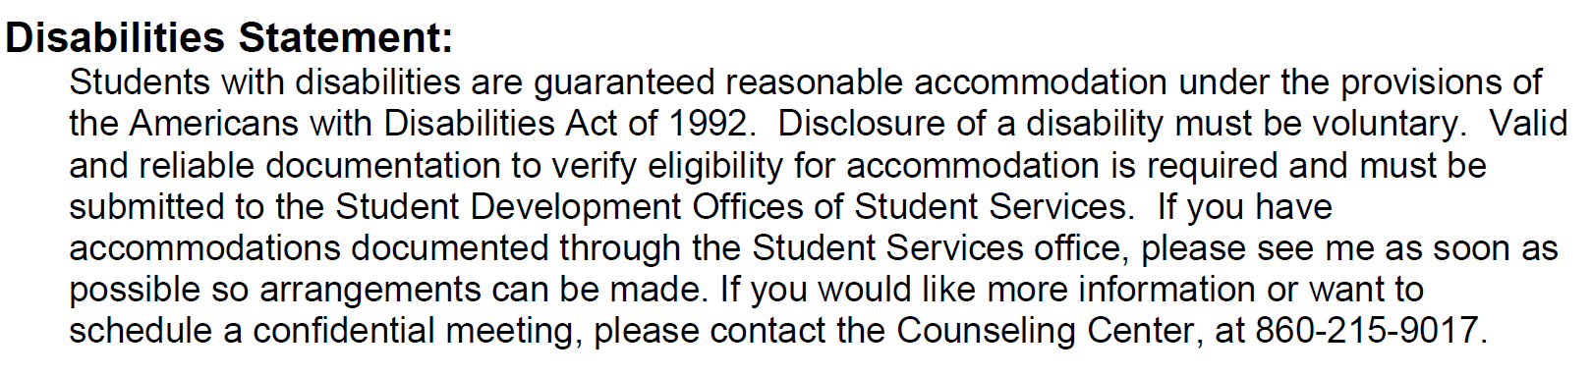
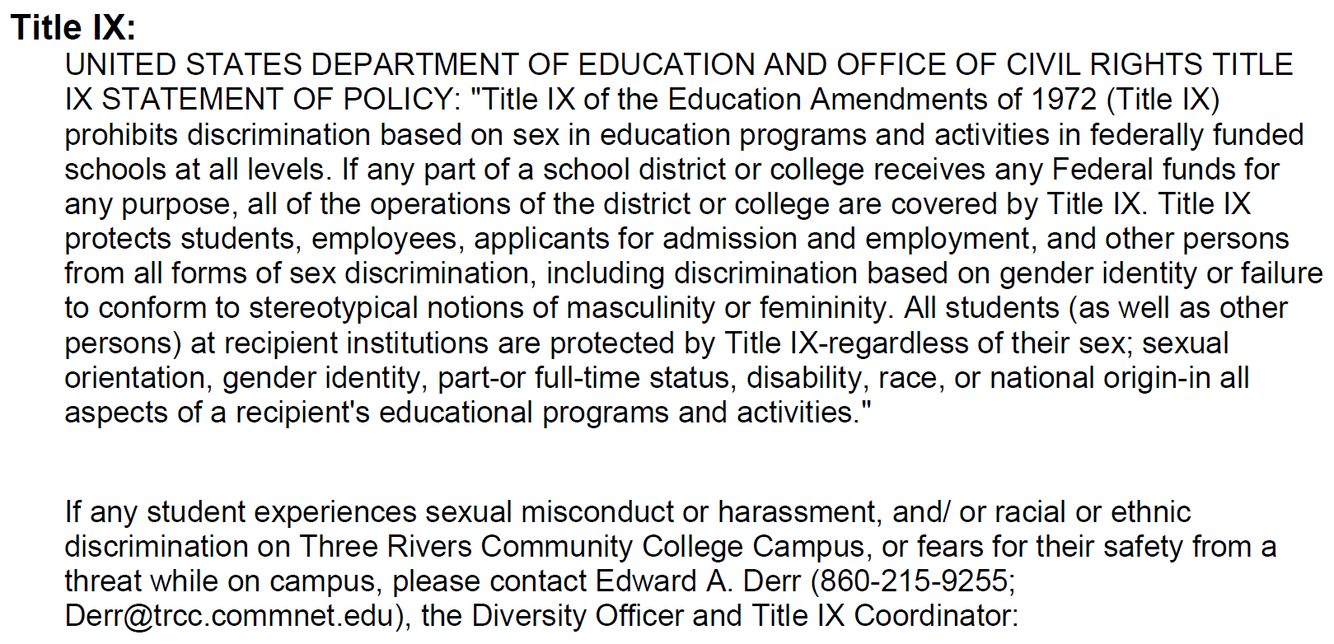

DIGICATION is an online learning portfolio provided by the college. Students are expected to maintain a portfolio. Please submit your worked out solutions to the Midsemester problem set on digication. Further directions will be given in early October.

