Syllabus

Mat 095I Beginning Algebra Fall 2018 CRN #32299

Professor June Decker

Office #C124 office phone: 860 215 9420 [jdecker@trcc.commnet.edu](mailto:jdecker@trcc.commnet.edu)

WebEx for virtual office hours: <https://ctedu.webex.com/join/JDeckertrcc.commnet.edu>meeting number 64 844 022

[www.MyOpenMath.com](http://www.MyOpenMath.com) Course ID is 21822 and enrollment key is ilovemath

Office hours: Monday 8-9:30 AM, Thursday 4-5, Virtual Office Hours on WebEx: Monday 7:30-9 PM

Software and TEXT: We will use material from Creative Commons – open source courseware. I will distribute hard copies in class and post them on Blackboard. You can also go to the course in MyOpenMath MOM - Go to MyOpenMath.com. Register using course number 21822 and enrollment key ilovemath .

**GRADING POLICY**:

1. 25% class participation and homework
2. 35 % is class room tests or quizzes
3. 10% is Problem set for the mid semester due Oct 10 is worth 10%
4. 10% is Problem set to review for the final exam Due Dec 5 is worth 10% of your grade.
5. 20% is Final Exam covering material from the entire semester is worth 20% of your grade. The part of the final exam that tests math skills will not allow you to use a calculator. The part of the final exam that tests word problems will allow you to use a calculator. No notes, no outside help of any sort is allowed on the final exam.

Final exam is Dec 12 in class

**COLLEGE WITHDRAWAL POLICY**

Course withdrawals are accepted up until the week before classes end – Dec 7 in person at student services and Dec 9 online. Specific dates are posted in the academic calendar and withdrawal forms are available online or at the Registrar’s office. The withdrawal does not have to be signed by the instructor, but it is strongly recommended that you speak with your instructor before withdrawing so we can discuss other options such as Incompletes. If you are receiving financial aid you must contact their office for approval before withdrawing. If necessary, you can withdraw over the phone by calling the Registrar’s Office at 860-215-9064

**ACADEMIC INTEGRITY POLICY**

All students are expected to demonstrate their knowledge of the material on each problem set, quiz and test. Any student caught cheating will receive a zero on that test or quiz or problem set. You may receive help of any kind on all your work except that the final exam is to be done by you and you alone without any notes. That is why the final exam is Proctored. Even though you are allowed to get help on any work your do (except the final exam) you must understand the content of the course and the problems you do – even if you get help with them – and you must be able to do the problem without help by the end of the semester. Help can take the form of communicating with another person, looking up how to do something from another textbook or from a source on the internet, looking at your notes, looking at an answer key, etc.

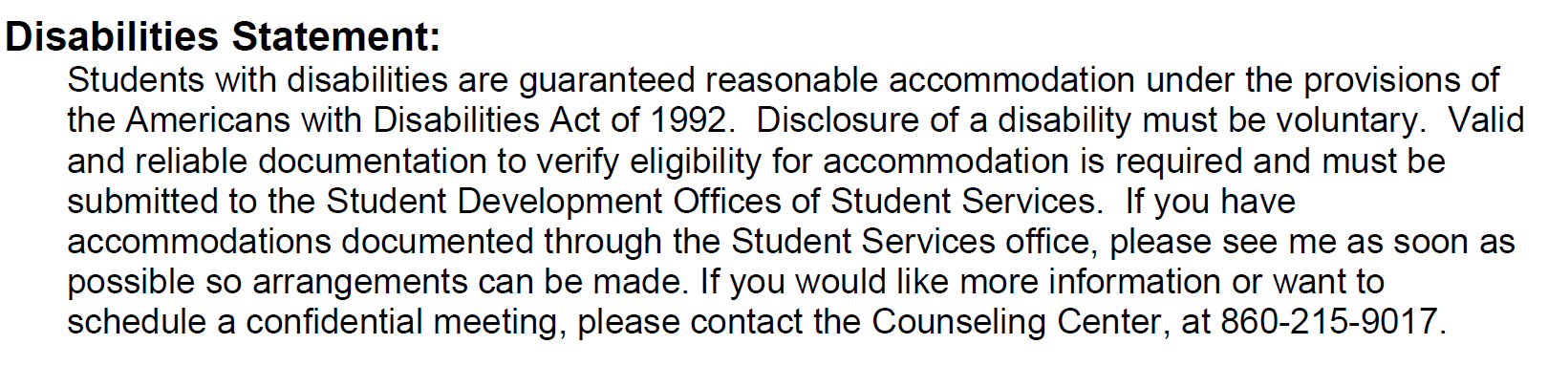

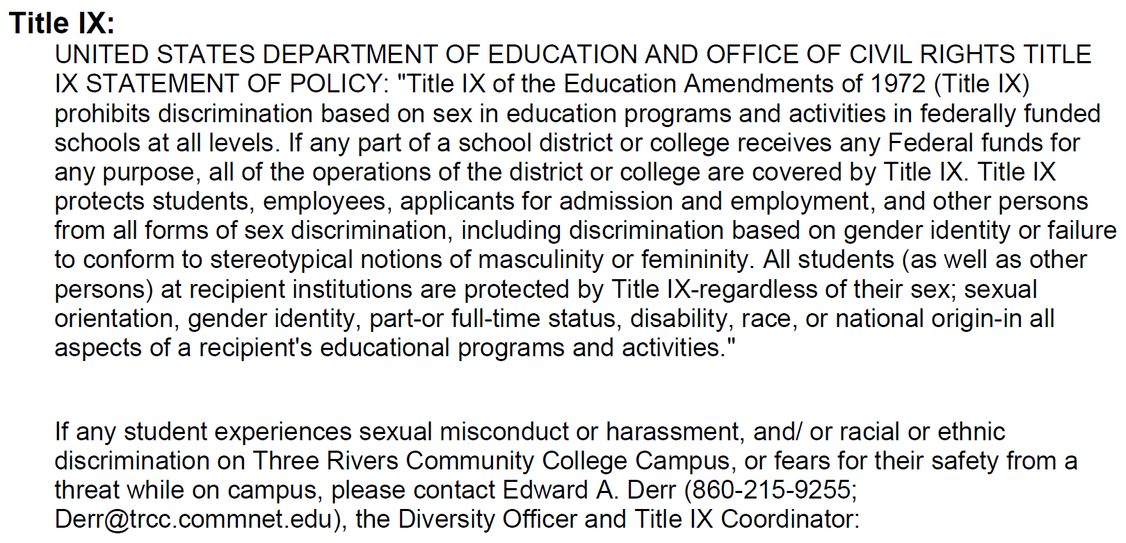

**DIGICATION** is an online learning portfolio provided by the college. Students are expected to maintain a portfolio. Please submit your worked out solutions to the Midsemester problem set on digication. Further directions will be given in early October.

**Math 095 COURSE OUTCOMES:**

1. **Rational Numbers – At the end of this course, a student should be able to**
2. Identify and distinguish between rational and irrational numbers
3. Use rational approximations of irrational numbers to compare the size of irrational numbers, locate them approximately on a number line diagram, and estimate the value of expressions (e.g., , )
4. **Expressions and Equations with Polynomials, Rational and Radical Expressions, and Integer Exponents – At the end of this course, a student should be able to**
5. Interpret parts of an expression, such as terms, factors, and coefficients and evaluate expressions for a given replacement value(s)
6. Add, subtract, and multiply polynomials. Divide polynomials by a monomial
7. Construct and interpret equations as two expressions set equal to each other
8. Manipulate formulas to highlight a quantity of interest, using the same reasoning as in solving equations. For example, rearrange Ohm’s Law  to highlight resistance 
9. Know and apply the properties of integer exponents to generate equivalent numerical expressions. For example, )
10. Use square root symbols to represent solutions to equations of the form , where is a positive rational number
11. Evaluate square roots of perfect squares
12. Know that numbers such as  are irrational
13. Express very large or very small quantities in scientific notation
14. Perform operations with numbers expressed in scientific notation
15. **Linear Equations in One Variable – At the end of this course, a student should be able to**
16. Solve linear equations and inequalities in one variable
17. Solve linear equations with rational number coefficients, including equations whose solutions require expanding expressions using the distributive property and collecting like terms
18. Create linear equations and inequalities in one variable and use them to solve real world applications
19. Recognize examples of linear equations in one variable with one solution, infinitely many solutions, or no solutions
20. **Linear Equations in Two Variables – At the end of this course, a student should be able to**
21. Interpret the rate and unit rate as the slope of the graph
22. Derive the equation for a line intercepting the vertical axis at  *and having a slope of* 
23. Identify parallel and perpendicular lines based on their slopes
24. Graph a linear equation in two variables
25. Construct a linear equation to model a linear relationship between two quantities. Determine and interpret the rate of change and initial value from a description of a relationship or from two  values, including reading these from a table or graph
26. Construct linear equations given a graph, a description of a relationship, or two input-output pairs (include reading these from a table) using point-slope form and slope-intercept form
27. **Systems of Linear Equations – At the end of this course, a student should be able to**
28. Understand that solutions to a system of two linear equations in two variables correspond to points of intersection of their graphs
29. Solve systems of two linear equations in two variables algebraically (using both substitution and addition methods), graphically (by hand and/or technology), Solve simple cases by inspection. *For example,*  *and*  *have no solution because*  *cannot simultaneously be*  *and* 
30. Recognize systems of linear equations with one solution, infinitely many solutions, or no solutions
31. Solve real-world problems leading to two linear equations in two variables
32. **Functions – At the end of this course, a student should be able to**
33. Understand that a function is a rule that assigns to each input exactly one output and that the graph of a function is the set of ordered pairs consisting of an input and the corresponding output
34. Interpret the equation  as defining a linear function, whose graph is a straight line
35. Use functions to model linear relationships between quantities
36. Use function notation. Evaluate functions for inputs in their domains
37. Graph linear functions and show intercepts
38. Recognize that linear functions have a constant rate of change and interpret the rate of change in the context of the problem
39. **Applications – At the end of this course, a student should be able to**
40. Apply geometric formulas for two and three-dimensional figures such as rectangles, circles, rectangular solids, cylinders, spheres, etc.
41. Apply the Pythagorean Theorem to determine unknown side lengths in right triangles in real-world and mathematical problems in two dimensions