Software Request Form
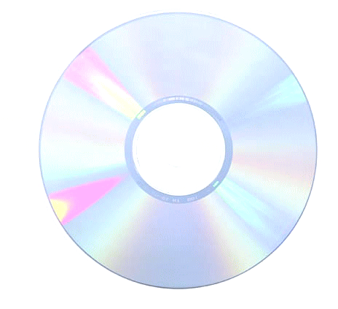

❑ Copy of the Software
Software Manufacturer:
Software Name:
Software Version:
Software Licensing Info (ie, key code):
(attach copy of license)
Support Web Site:
Support Phone Number:
Machine(s) to be installed on:

Person Requesting Installation:

Date:

Department Chairperson Signature (if being installed in a college computer lab, tutoring lab, or Library):_______________________________________

FOR COMPUTER LABS:
Requests for new software for fall semesters must be made by July 1st.
Requests for new software for spring semesters must be made by November 1st.

Completed forms must be sent to the IT-Help Desk

