Former Students (attended 2 or more years ago)
- eTranscript. - Online
- Go to: www.threerivers.edu
- Move pointer over Life After TRCC
- Move pointer to Alumni
- Click Transcript Request
Recent and Current Students (attended within the past 2 years)
- Go to https://my.commnet.edu
- Login using your Net ID and password*
- If you do not remember your Net ID or password, please use the online self-help tool at http://www.commnet.edu/netid
- Click “Banner Self Service” link in the upper right hand corner
- Click “Student Records”
- Click “Transcripts”
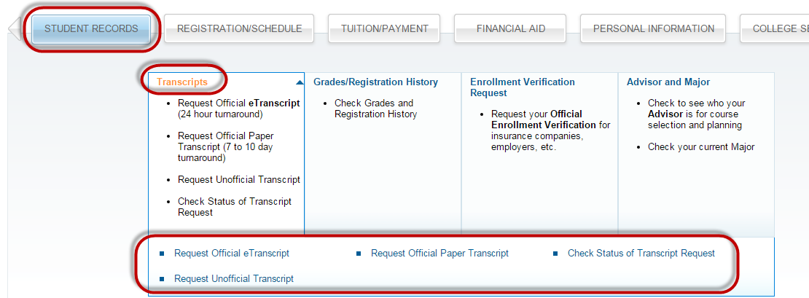
- Select your choice of transcript

eTranscript - Official
- Click on Request Official eTranscript.
- Click on Access the Transcript Ordering Site
- Follow the directions on the Transcript Ordering site to have your eTranscript electronically sent to the college/university, yourself, or a third party.
- There is a 24 hour turnaround on an eTranscript request.
- To check the status, log into myCommNet, go to Banner Self-Service, STUDENT RECORDS, Transcripts, and click on Check Status of Transcript Request from the Transcripts sub-menu to see if your transcript has been sent electronically.
- You will receive confirmation emails regarding your request.

Important Transcript request information:
- Transcripts cannot be faxed or produced while you wait
- No telephone requests will be accepted
- Transcripts will not be issued if student has outstanding financial obligations to the college

